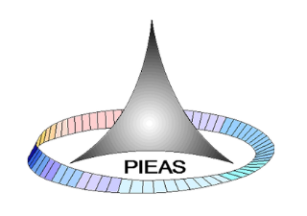
ME-409
Heat Transfer, Refrigeration and Air Conditioning Lab
Lab Manual

Contents
Experiment 0 11
0.1 Course Learning Outcomes 11
0.2 Course Contents 11
0.3 Recommended Texts 11
0.4 Guidelines for Lab Report 11
0.5 Contents 11
0.5.1 Cover Page 11
0.5.2 Abstract 12
0.5.3 Introduction 12
0.5.4 Theory 12
0.5.5 Procedure 13
0.5.6 Observations & calculations 13
0.5.7 Conclusions 13
0.5.8 Discussion 13
0.5.9 References 13
0.6 Format 13
0.7 Caption 14
0.8 References 14
0.9 General Guidelines in a Lab for safety 14
EXPERIMENT 1 16
Experiment 1 17
1.1 Learning Objectives 17
1.2 Introduction 17
1.3 Experimental Setup 19
1.4 Theory 21
1.5 Procedure 22
1.6 Observation and Calculations 22
1.7 Precautions 24
1.8 Result and Discussion 24
1.8.1 Data Analysis 24
1.8.2 Points of Discussion in the Lab Report 24
EXPERIMENT 2 25
Experiment 2 26
2.1 Learning Objectives 26
2.2 Introduction 26
2.3 Experimental Setup 27
2.4 Theory 28
2.4.1 Heat Exchanger Analysis 28
2.5 Procedure 32
2.6 Observation and Calculations 33
2.7 Precautions 36
2.8 Result and Discussion 36
2.8.1 Data Analysis 36
2.8.2 Points of Discussion 36
EXPERIMENT 3 37
Experiment 3 38
3.1 Learning Objectives 38
3.2 Introduction 38
3.3 Experimental Setup 38
3.4 Theory 39
3.4.1 Condensation 39
3.4.2 Film Wise Condensation 40
3.4.3 Dropwise Condensation 41
3.5 Procedure 42
3.5.1 General Operating Procedure 42
3.5.2 General Start Up Procedure 42
3.5.3 Procedure of Experiment 43
3.6 Observation and Calculation 43
3.7 Precaution 45
3.8 Result and Discussion 45
3.8.1 Graphs 45
3.8.2 Points to be discussed 46
EXPERIMENT 4 47
Experiment 4 48
4.1 Learning Objectives 48
4.2 Introduction 48
4.3 Experimental Setup 48
4.4 Theory 50
4.4.1 Free Convection 50
4.4.2 Forced Convection 50
4.5 Procedure 51
4.5.1 General Start-up Procedure: 51
4.5.2 Procedure of Experiment 52
4.6 Observation and Calculations 53
4.7 Result and Discussion 55
4.7.1 Data Analysis 55
4.7.2 Points to be discussed 55
EXPERIMENT 5 56
Experiment 5 57
5.1 Learning Objectives 57
5.2 Introduction 57
5.3 Experimental Setup 57
5.4 Theory 58
5.4.1 Extended Surfaces 58
5.4.2 Temperature Distribution along an Extended Surface 59
5.5 Procedure 60
5.6 Observation and Calculations 61
5.8 Result and Discussion 63
5.8.1 Data Analysis 63
5.8.2 Points to be discussed 63
EXPERIMENT 6 64
Experiment 6 65
6.1 Learning Objectives 65
6.2 Introduction 65
6.3 Experimental Setup 65
6.4 Theory 66
6.4.1 Inverse Square Law for Heat 66
6.4.2 Stefan-Boltzmann Law 67
6.5 Procedure 67
6.5.1 General Start up Procedure 67
6.5.2 Procedure of Experiment 68
6.6 Observation and Calculations 69
6.7 Precautions 69
6.8 Result and Discussion 70
6.8.1 Data Analysis 70
6.8.2 Points to be discussed 70
EXPERIMENT 7 71
Experiment 7 72
7.1 Learning Objectives 72
7.2 List of Equipment 72
7.3 Introduction 72
7.4 Theory 72
7.4.1 Refrigerants 73
7.4.2 Basic Components of Simple Vapor Compression Cycle 74
7.4.3 Thermodynamic Cycle and Property Diagrams 79
7.4.4 Performance of Vapor Compression System 80
7.5 Experimental Setup 80
7.6 Experimental Procedure 81
7.7 Observations 82
7.8 Calculations 87
7.9 Discussion and Conclusion 88
EXPERIMENT 8 89
Experiment 8 90
8.1 Learning Objectives 90
8.2 List of Equipment 90
8.3 Introduction 90
8.4 Theory 90
8.5 Experimental Setup 92
8.6 Experimental Procedure 93
8.7 Observations 94
8.8 Calculations 95
8.9 Discussion and Conclusion 100
EXPERIMENT 9 101
Experiment 9 102
9.1 Learning Objective 102
9.2 List of Equipment 102
9.3 Introduction 102
9.4 Theory 102
9.4.1 Simple Vapor Absorption System 103
9.4.2 Characteristics of Refrigerant-Absorbent Combination 104
9.4.3 Pumpless Vapor Absorption System 105
9.4.4 Fundamental Principle of Pumpless Vapor Absorption System 105
9.5 Experimental Setup 107
9.5.1 Apparatus Flow Diagram 108
9.6 Experimental Procedure 109
9.7 Observations 110
9.8 Discussion and Conclusion 114
EXPERIMENT 10 115
Experiment 10 116
10.1 Learning Objectives 116
10.2 List of Equipment 116
10.3 Introduction 116
10.4 Theory 116
10.4.1 Components of Cooling Tower 118
10.4.2 Cooling Tower Performance Parameters 119
10.5 Experimental Procedure 120
10.6 Observations and Calculations 121
10.7 Discussion and Conclusion 122

List of Figures
Figure 1-1: Range of thermal conductivity for various phases of matter at normal temperatures and pressure [1] 18
Figure 1-2: Schematic of thermal conduction system with constant and variable X-section 20
Figure 1-3: Thermal Conduction System Model 9051 20
Figure 2-1: Types of heat exchangers – concentric tube (a) parallel flow (b) counter flow; (c) shell and tube (d) cross flow 27
Figure 3-1: Experimental Setup 39
Figure 4-1: Experimental Setup 49
Figure 4-2: Schematic of Experimental Setup 49
Figure 4-3: Typical graph of power against surface temperature 50
Figure 4-4: Typical graph of air velocity against surface temperature 51
Figure 5-1: Experimental setup 58
Figure 5-2: Plate-type fin 59
Figure 5-3: Pin-type fin 59
Figure 5-4: Typical graph of air velocities against surface temperature 59
Figure 5-5: Graph of surface temperature against distance from back plate 60
Figure 6-1: Radiation heat transfer Apparatus 66
Figure 6-2: Schematic of Apparatus 66
Figure 6-3: Inverse square law 67
Figure 7-1: A schematic diagram of simple vapor compression system 74
Figure 7-2: Distinction between low pressure side and high pressure side 75
Figure 7-3: A capillary tube 77
Figure 7-4: Schematic diagram of thermostatic expansion valve 78
Figure 7-5: Standard vapor compression system and T-s diagram of cyle 79
Figure 7-6: P-h diagram of a vapor compression cycle 80
Figure 7-7: EM-872 refrigeration technology demonstration module 81
Figure 7-8: P-h diagram for thermostatic expansion valve 83
Figure 7-9: P-h diagram for capillary tube (6m) 84
Figure 7-10: P-h diagram for capillary tube (4m) 85
Figure 7-11: P-h diagram for capillary tube (2m) 86
Figure 8-1: Difference between refrigerators along with T-s diagram of cycle 91
Figure 8-2: T-H 3135 heat pump air to water 92
Figure 8-3: P-h diagram for R134-a 96
Figure 8-4: P-h diagram for R134-a 97
Figure 8-5: P-h diagram for R134-a 98
Figure 8-6: P-h diagram for R134-a 99
Figure 9-1: A simple schematic diagram of vapor absorption system 102
Figure 9-2: A simple vapor absorption system 103
Figure 9-3: Pumpless vapor absorption system 106
Figure 9-4: Pumpless vapor absorption system apparatus 107
Figure 9-5: Apparatus flow diagram 109
Figure 10-1: Cooling tower schematic 116

List of Tables
Table 1-1: Temperature values in cylindrical bar 22
Table 1-2: Coolant Parameters 23
Table 2-1: Experimental and calculated values of temperatures, flow rates and heat transfer rates. 33
Table 3-1: Observation Table for film wise condensation 43
Table 3-2: Observation table of Dropwise condensation 44
Table 4-1: Observation table for free convection 53
Table 4-2: Observation table for forced convection 54
Table 4-3: Observation table for forced convection with varying speed 54
Table 5-1: Observation table for extended surfaces 61
Table 5-2: Observation table for temperature distribution 62
Table 6-1: Observation table for Inverse square law 69
Table 6-2: Observation Table for Stefan-Boltzmann Law 69
Table 7-1: Observations for experiment 7 82
Table 7-2: Calculations for experiment 7 87
Table 8-1: Observations for experiment 8 94
Table 8-2: Calculations for experiment 8 95
Table 9-1: Observations for experiment 9 110
Table 10-1: Observations and calculations for experiment 10 121

Experiment 0

0.1 Course Learning Outcomes
Contact Hours: |  | Credit Hours:
Theory | = 0 | Theory | = 0.0
Practical | = 48 | Practical | = 1.0
Total | = 48 | Total | = 1.0
Upon successful completion of the course, the student will be able to:
No | CLO Statement | Domain | Taxonomy  Level | PLO
1. | DISPLAY basic proficiency in operation of the apparatus and PERFORM the experiment to determine the solution of the engineering problems related to the subject. | Psychomotor | 4 | 4
2. | Communicate the learned concepts using different media i.e., verbal and written. | Affective | 2 | 10
3. | Manifest the professional responsibilities and norms of engineering practice. | Affective | 3 | 8

0.2 Course Contents
The experiments in this lab complement the knowledge gained in theory lectures.

0.3 Recommended Texts
Lab manuals

0.4 Guidelines for Lab Report
Lab report must be submitted/checked within 7 days effectively after the experiment is conducted. Lab report may not be accepted/checked after due date and lab report marks may be deducted as per criteria.

0.5 Contents

0.5.1 Cover Page
The cover page should contain the followings
- Lab Name
- Experiment Name
- Students’ Name
- Group #
- Lab Instructor Name
- Date on which lab Experiment was conducted (See the Lab schedule for it)
- Submission date of Lab Report
The format and Alignment and arrangement of above mentioned is student’s own choice.

0.5.2 Abstract
The abstract contains summary lab activity done and contains the following main points.
- Purpose/ objective(s) of the experiment
- Main results in the experiment
- Main results of experiment
- Main conclusion
The abstract should be of one paragraph with words not more than 200 words.

0.5.3 Introduction
This section is meant for describing the worth/importance/significance of your work. As a part of arguments for proving your work a useful one it is logical to briefly point out the similar work already done by others but a detailed literature review is not a part of introduction.
As a part of description of the importance of work you may also justify your choice of problem solution methodology. When there are potentially more than one approaches available for the solution of the same problem; it is logical to opt for the best available choice giving due regard to the resource constraints.
Through INTRODUCTION of the report you try to convince the reader that your work is really useful. According to a researcher “Introduction is setting up the scene”.
Wherever necessary there may be a separate section of theory but it must not be dragged into introduction.

0.5.4 Theory
It is an optional section and is included to appraise the reader the theory of your work. In the lab reports we normally do not recommend to include this section.

0.5.5 Procedure
In this section it is recommended to enlist the sequential steps for taking proper data. Wherever applicable a block diagram of the experimental set up is to be included. The diagrams should be properly labeled.
While writing a lab experiment procedure do not adopt the style of instructor. It is generally recommended to use past tense and passive voice. In technical writings the use of “I” and “We” is generally not appreciated.

0.5.6 Observations & calculations
It includes tabulation of observed data and calculations are required to be made for the meaningful analysis of results. Formulae involved in calculations need to be mentioned along with a sample of calculations. Graphical representation is a more effective way (than tabulation) of the presentation of results.

0.5.7 Conclusions
The conclusion expresses the main points (one or two) of the final results the lab.

0.5.8 Discussion
In this section you are supposed to justify your results. The expected results need to be justified with the help of some standard references. Reasons should be mentioned for the unexpected results. In this case all possible sources of error need to be looked at while giving consideration to the individual contribution of each source of error towards the overall error in the final results. Comparison of results with similar investigations (already made using same or different technique) is an essential component of the DISCUSSION section of a report.

0.5.9 References
Whatever information (other than own work of present report) has been used in writing of report needs to be properly referred (using a standard format of referring a book, a paper of a journal, a paper of a conference and information on a website). It is not sufficient to put a list of references at the end of a report. These references should also appear as numbers in square brackets in the main body of report.

0.6 Format
The following format should be followed for writing report of a lab experiment. Title page is exempted from these format guidelines.
- Font should be Times New Roman (Whole Report)
- Line Spacing = 1.15 (whole report)
- Title should be of font size = 16, Bold,
- Heading 1 should be of font size = 14, Bold
- Heading 2 should be of font size = 13, Bold
- Heading 3 should be of font size = 12, Italic, Bold
- Page # should be added.
- List of figure, List of table and Table of content.

0.7 Caption
For table: Above the Table aligned in center with table. Font size: 10
For Figure: Below the Figure aligned in center with figure. Font size: 10

0.8 References
Should be added in IEEE/ other recognized format using Endnote/word.
Note: In case of WRITTEN REPORT, the content should be same except guidelines given under heading Format.

0.9 General Guidelines in a Lab for safety
The following guidelines are to be followed in a lab.
- No Laboratory work should be carried out without supervision of the Instructor or Lab technician.
- Do only experiment assigned to you and do not perform unauthorized experiment by yourself.
- Do not play with the equipment that are not part of experimental setup.
- Never leave an in progress experiment unattended.
- Do not exceed voltage limits of devices when plugging them into electrical outlets.
- Do not try to repair or modify any lab experiments unattended.
- Don not exceed voltage limits of devices when plugging them into electrical outlets.
- Don not try to repair or modify any lab equipment.
- Always wear a protective lab coat/overall and safety shoes. Long hair should be tied back.
- Be alert to unsafe conditions and actions and call them to the attention of the instructor immediately.
- Be careful not to touch any heated surfaces as they might cause a burn.
- Don’t touch live conductor or wire with the bare hand.
- Don’t work in lab all alone.
- Report all damages to lab instructor immediately.
- Leave equipment in proper places at the end of your experiments and cleanup.
- After completion of the experiments, return the items borrowed, if any.
- Don’t run or paly in the lab.
- Eating drinking, smoking or chewing of gum is not permitted in the laboratory.
- Don’t use cell phones inside the laboratory.

EXPERIMENT 1
Date: ________________
ABSTRACT

(Abstract to be written in Times New Roman, 12, Justify)

Experiment 1
Study of Heat Conduction Through Copper Bars

1.1 Learning Objectives
- The students will learn about the phenomenon of heat conduction through solid metallic bars
- The students will evaluate the thermal conductivity of copper experimentally using “Thermal Conduction System – Model 9051”
- Value of conductivity will be used to determine the conduction through constant area copper bars

1.2 Introduction
When a temperature gradient exists in a stationary medium, which may be a solid or a fluid, we use the term conduction to refer to the heat transfer that will occur across the medium. The physical mechanism of conduction involves concepts of atomic and molecular activity, which sustains the transfer of energy from the more energetic to the less energetic particles of a substance due to interactions between the particles.
Consider a gas occupying the space between two surfaces maintained at different temperatures and assume that there is no bulk motion. We associate the temperature at any point with the energy of the gas molecule. This energy is related to the random translational motion, as well as to the internal rotational and vibrational motions of the molecules.
Higher temperatures are associated with higher molecular energies, and when neighboring molecules collide, as they are constantly doing, a transfer of energy from the more energetic to the less energetic molecules must occur. In the presence of a temperature gradient, energy transfer by conduction must then occur in the direction of decreasing temperature. We may speak of the net transfer of energy by this molecular motion as a diffusion of energy. The situation is much the same in liquids, although the molecules are more closely spaced and the molecular interactions are stronger and more frequent. In a solid, conduction is attributed to atomic activity in the form of lattice vibrations and electron migration. We treat the conduction phenomena by Fourier’s law, which is defined in terms of an important material property, defined as thermal conductivity.
It is important to emphasize that he origin of Fourier’s law is phenomenological. That is, it is developed from observed phenomena - the generalization of extensive experimental evidence rather than being derived from first principles. Mathematically, it is defined as [1-3]
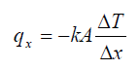
Where q_{x} is heat transfer rate in Watts; A is heat transfer area normal to direction of flow in m²; k is thermal conductivity in W/m.K; ΔT is temperature difference in K; Δx is the rod length in m.
The above expression defines the important material property, thermal conductivity, one of most important transport properties that you will encounter in performing conduction analyses. Tabulated values of the thermo-physical properties required for solution of heat transfer problems are provided in your textbook. A typical range of thermal conductivity values for various matter are shown in Fig. 8.1.
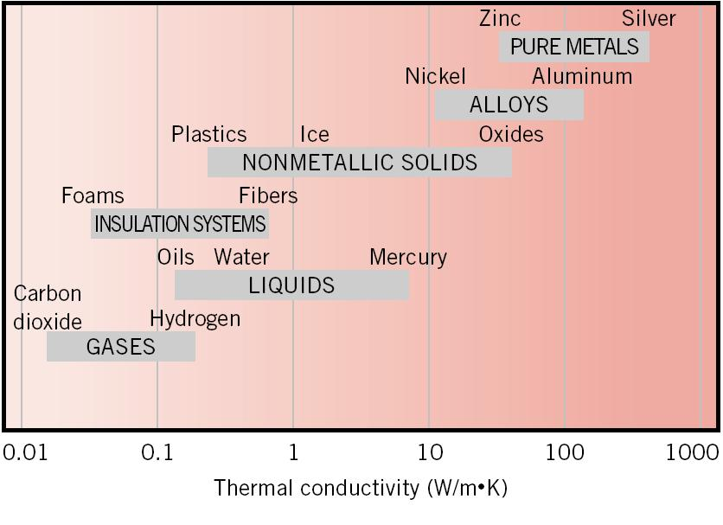
Figure 1-1: Range of thermal conductivity for various phases of matter at normal temperatures and pressure [1]
It is thus important to know thermal conductivity of various conducting and insulating materials that are used in many industrial processes. In this regard, we will conduct an experiment to determine heat transfer rate through constant and variable solid areas. First, we will determine thermal conductivity of copper bars and then use simple analysis to calculate heat transfer rates through these bars.

1.3 Experimental Setup
The objectives of this experiment are achieved through the use of Thermal Conduction System, Model 9051 (refer to Figures 8.2 and 8.3) available in our laboratory. The system consists of two hot plate type heat sources copper bars (unit 3 and unit 4) and 10 thermocouple junctions on each bar. Unit 3 has a tapered bar and Unit 4 has a cylindrical bar as indicated in the figure.
It should be noted that these units provide vertical heat flux paths. Referring to Figure 1.3, the one at the left is a cylindrical bar while the one at the right is a tapered bar. Each bar is in contact at its lower end with its own hot plate. Contact for the tapered bar is at the smaller end. The maximum electrical input through the plate is 750 Watts. The surface temperature can be modulated between 5 ºF above the room temperature to 400 ºF. A metal plate attached to the actual heater plate functions as a heat source, concentrating the heat flux concentrically into the test bar. Both bars are of the same diameter at the upper end and in contact with a non-immersion type fluid-cooled heat sink. Instrumentation and control of coolant flow through these heat sinks is provided to monitor and control the heat flow rates through the bars.
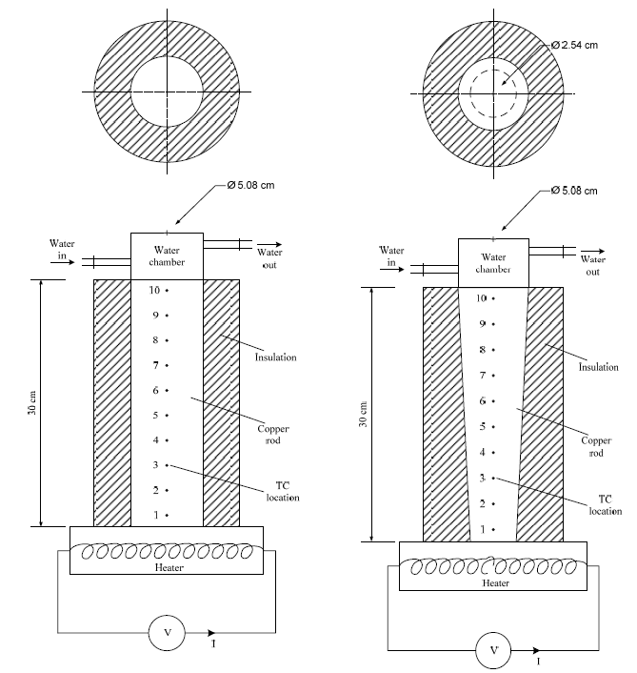
Figure 1-2: Schematic of thermal conduction system with constant and variable X-section
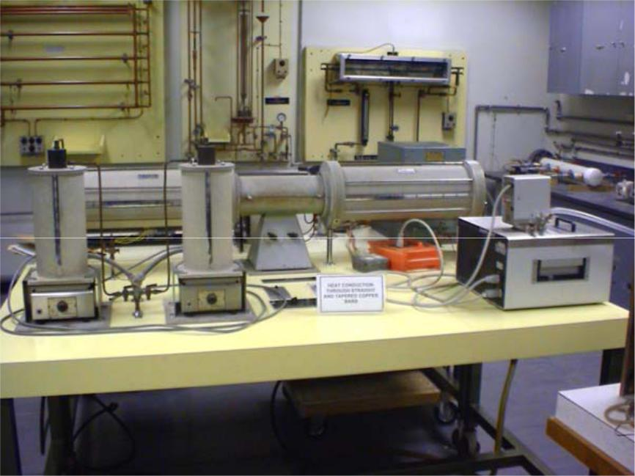
Figure 1-3: Thermal Conduction System Model 9051

1.4 Theory
Under steady-state condition, heat flux (in W/m²) through the constant cross-section cylindrical bar is constant over the entire length. As a result, the heat flux is given by
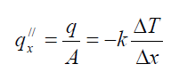
The quantity of heat, which is conducted through the rod, is transferred to the cooling water. Therefore, the heat transferred to the cooling water can be expressed as
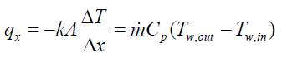
Now from the above equation, we can express thermal conductivity, k as
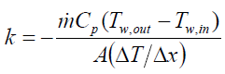
Where
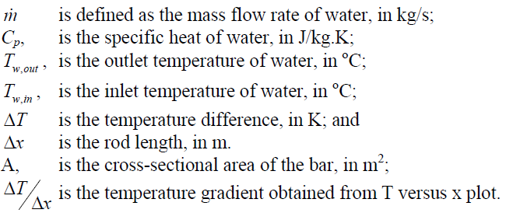
It is important to recognize that in the tapered bar, the heat flux is not constant along it. In fact, it is the heat transfer rate that remains constant, while the flux increases with the decrease of cross-sectional area. The temperature distribution through the bar can be calculated by using Equation 8.1 in the limiting condition; i.e., when x → 0 . This gives after separating the variables [1-3],
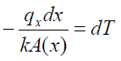
Integrating, the left-hand side from x₁ to x, and the right-hand side from T₁ to T, we have
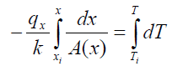
Notice that A(x) can be expressed in terms of x and d(x). From the geometry of the tapered bar, d(x) can be expressed as
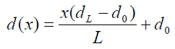
Where
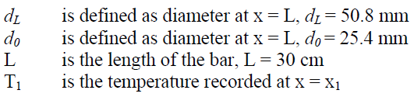
The desired temperature distribution can be obtained from above equations.

1.5 Procedure
The following experimental procedure should be followed while conducting this experiment:
- Establish constant and steady cooling water flow of about 400 mL/min
- Turn on heaters to Units 3 and 4 - set each one to 500 W. Allow the system to reach steady-state conditions.
- Start recording temperatures using a digital thermometer. Note that two selector switches on the apparatus allow you to select whatever thermocouple you wish to read.
- Measure cooling water flow rates using the flow rate-measuring device provided by your instructor.
- Record data at least once every 15 minutes, and continue until steady conditions have reached. You may have to wait for about an hour after setting up the apparatus to allow the unit to reach the desired state conditions.

1.6 Observation and Calculations
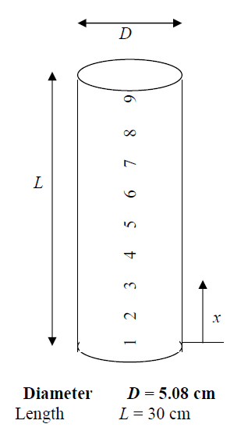
Table 1-1: Temperature values in cylindrical bar
Thermocouple # | x (m) | Temperature (ºC)
 |  | Q = 300W | Q = 400 W | Q = 500 W
1 | 0.0493
2 | 0.0739
3 | 0.0986
4 | 0.1229
5 | 0.1476
6 | 0.1722
7 | 0.1969
8 | 0.2215
9 | 0.2461
10 | 0.2708

Table 1-2: Coolant Parameters
Coolant Parameters | Q = 300 W | Q = 400 W | Q = 500 W
Inlet Temperature (ºC)
Outlet Temperature (ºC)
Flow Rate (l/min)
Sample Calculations:

1.7 Precautions
- The apparatus should reach steady state.

1.8 Result and Discussion
(Guidelines for this section is mentioned below)

1.8.1 Data Analysis
In your report, you are required to present the following:
- On a single graph plot the temperature versus position along the bar length for both the bars.
- Using data for constant cross-sectional area bar, calculate the thermal conductivity for the copper bar and compare with the value given in your heat transfer text.
- For the tapered bar, derive an equation that can be used to predict temperature distribution as a function of x.
- Plot the temperature distribution from your equation and the one obtained from your experiment for the tapered bar.
- Carry out sensitivity analysis of k in terms of input (measured) variables.

1.8.2 Points of Discussion in the Lab Report
- What effect does the heat input have on the value of thermal conductivity? What effect does theory tell us it should have?
- What differences do we see between the constant cross section and variable cross section bars in terms of heat flux?
- What errors may be introduced by measuring thermal conductivity by this method?
- Is it important to consider heat losses from the insulation?

EXPERIMENT 2
Date: ________________
ABSTRACT

(Abstract to be written in Times New Roman, 12, Justify)

Experiment 2
Study of Characteristics of Double Pipe Heat Exchanger

2.1 Learning Objectives
- The students will learn to evaluate the performance characteristics of a heat exchanger
- Difference in the performance of heat exchanger in parallel and counter flow arrangement will be studied

2.2 Introduction
The technology of heating and cooling of systems is one of the most basic areas of mechanical engineering. Wherever steam is used, or wherever hot or cold fluids are required we will find a heat exchanger. They are used to heat and cool homes, offices, markets, shopping malls, cars, trucks, trailers, aeroplanes, and other transportation systems. They are used to process foods, paper, petroleum, and in many other industrial processes. They are found in superconductors, fusion power labs, spacecrafts, and advanced computer systems. The list of applications, in both low and high tech industries, is practically endless.
Heat exchangers are typically classified according to flow arrangement and type of construction. In this introductory treatment, we will consider three types that are representative of a wide variety of exchangers used in industrial practice. The simplest heat exchanger is one for which the hot and cold fluids flow in the same or opposite directions in a concentric-tube (or double-pipe) construction. In the parallel-flow arrangement of Figure 2.1a, the hot and cold fluids enter at the same end, flow in the same direction, and leave at the same end. In the counter flow arrangement, Figure 2.1b, the fluids enter at opposite ends, flow in opposite directions, and leave at opposite ends. A common configuration for power plant and large industrial applications is the shell-and-tube heat exchanger, shown in Figure 2.1c. This exchanger has one shell with multiple tubes, but the flow makes one pass through the shell. Baffles are usually installed to increase the convection coefficient of the shell side by inducing turbulence and a cross-flow velocity component. The cross-flow heat exchanger, Figure 2.1d, is constructed with a stack of thin plates bonded to a series of parallel tubes. The plates function as fins to enhance convection heat transfer and to ensure cross-flow over the tubes. Usually it is a gas that flows over the fin surfaces and the tubes, while a liquid flows in the tube. Such exchangers are used for air-conditioner and refrigeration heat rejection applications.
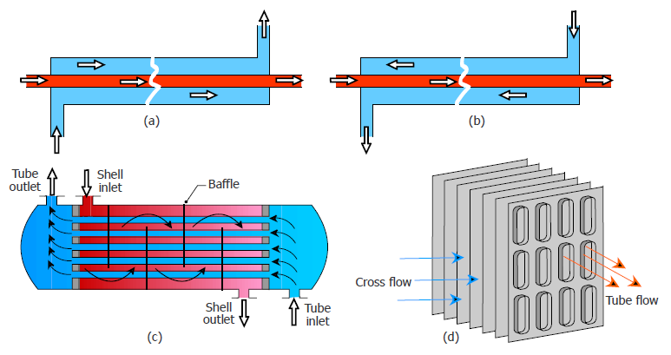
Figure 2-1: Types of heat exchangers – concentric tube (a) parallel flow (b) counter flow; (c) shell and tube (d) cross flow

2.3 Experimental Setup
The objectives of the heat exchanger experiments are achieved through the use of a bench mounted double-pipe heat-exchanger unit installed in MEL PIEAS. The schematic of the experimental facility is shown in Figure 2.2. The unit consists of two passes which will be used during the experiment. The hot fluid flows in the inner tube, while the cold in outer tube. The cold fluid is provided from overhead water tank while hot fluid is provided by means of a water bath. It is important that water at constant temperature is provided to both fluid circuits. Two temperature gauges are available for both the hot and cold fluid temperature measurements. The flow rates of hot and cold fluids are measured using rotameters, connected to the inner and outer tubes. Notice that the measurements would be taken for temperatures and flow rates for both (a) parallel and (b) counter-flow arrangements. It is very important that the water flow through the tubes reaches stable and steady state conditions before recording the following parameter for both parallel and counter flow conditions.
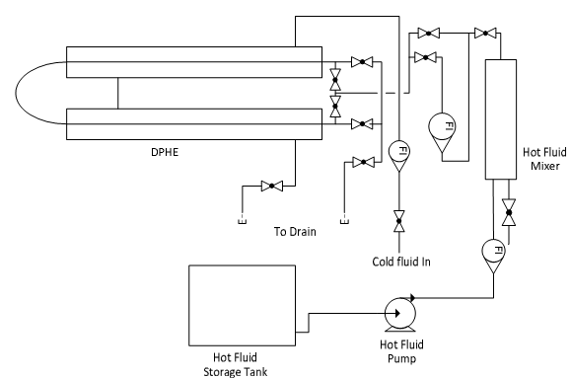
Figure 2-2: Schematic diagram of experimental facility

2.4 Theory

2.4.1 Heat Exchanger Analysis
The concept of overall heat transfer resistance or coefficient that you were introduced earlier in your heat transfer course, if we apply this concept to a, for example, double-pipe heat exchanger, the total resistance is the sum of the individual components; i.e., resistance of the inside flow, the conduction resistance in the tube material, and the outside convective resistance, given by
(Eq. 1)
where subscripts i and o refer to inner and outer heat-transfer surface areas, respectively, t is the wall thickness, and is the logarithmic mean heat transfer area, defined as
(Eq. 2)
The total heat transfer resistance can be defined in terms of overall heat transfer coefficient based on either outer or inner areas, as long as the basis is clearly spelled out. For example, based on outer area, we have
(Eq. 3)
which after simplifying yields the overall heat transfer coefficient based on inner and outer areas, respectively as [1]
(Eq. 4)
(Eq. 5)

where the inner and outer heat-transfer areas, as well as the wall thickness, and the logarithmic mean heat transfer area, in terms of tube inner and out diameters and length L, are given, respectively, as

(Eq. 6a)
(Eq. 6b)
(Eq. 6c)
(Eq. 6d)
We note from the above equations that if the wall thickness is negligible, for example, in thin tube heat exchangers or the thermal conductivity of the tube material is very high, the conduction resistance through the tube may be neglected in Equations (4.4) and (4.5) to give
(Eq. 7)
The convection coefficients for the inlet and outlet side of the heat exchanger tube can be estimated using empirical correlations appropriate for the flow geometry and conditions. For the double pipe heat exchanger in MEL PIEAS such a correlation is given as
(Eq. 8)
Where
(Eq. 9)
Prandtl number is given as
(Eq. 10)
Here Re represents Reynolds number given as
(Eq. 11)
There are two types of Reynolds number, one based on wetted perimeter called wetted Reynolds number Re_{w} and other based on heated perimeter called heated Reynolds number Re_{h}. These perimeters appear in definition of Hydraulic Diameter HD.
(Eq. 12)
2.4.2 Heat Transfer
The general heat exchanger equation is written in terms of the mean-temperature difference between the hot and cold fluid, ΔT_{m} as
(Eq. 13)
This equation, combined with the First Law equations, defines the energy flows for a heat exchanger. It can be expressed in terms of the temperature change of the hot and cold fluids, as
(Eq. 14)
where and are the hot and cold fluid capacitance rates, respectively.

2.4.3 Log Mean Temperature Difference (LMTD)
Heat flows between the hot and cold streams due to the temperature difference across the tube acting as a driving force. As seen in Fig. 2, the difference will vary with axial location so that one must speak in terms of the effective or integrated average temperature differences.
The form of the average temperature difference, ΔT_{m}, may be determined by applying an energy balance to differential control volumes (elements) in the hot and cold fluids. As shown in Fig. 2, for the case of parallel flow arrangement, each element is of length dx and the heat transfer surface area is dA. It follows for the hot and cold fluid as [1-3]
(Eq. 15)
The heat transfer across the surface area dA may be expressed by the convection rate equation in the differential form as
(Eq. 16)
where dT = T_{h} - T_{c} is the local temperature difference between the hot and cold fluids.
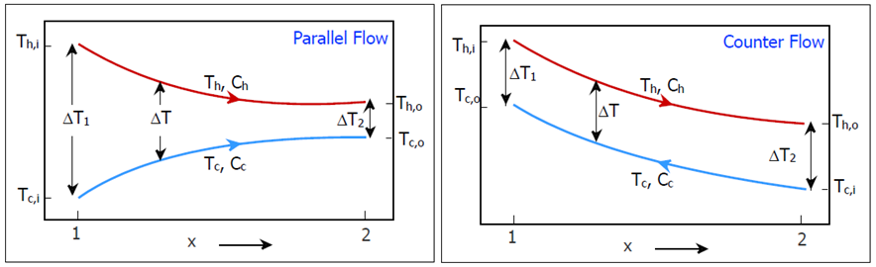
Figure 2-3: Temperature differences between hot and cold process streams
To determine the integrated form of Equation 16, we begin by substituting Equation 15 into the differential form for the temperature difference,

(Eq.1 7)

to obtain

(Eq. 18)
(Eq. 19)

Substituting and from the fluid energy balances, Equations 15 and integrating, we get after some manipulation,

(Eq. 20)

Comparing the above expression with Equation 13, we conclude that the appropriate mean temperature difference is the log mean temperature difference, ΔT_{lmtd}. Accordingly, we have

(Eq. 21)
Where

(Eq. 22)
(Eq. 23)
A similar derivation can be shown for counter-flow heat exchangers; however, the temperature difference as shown in Figure 2, will be
(Eq. 24)
(Eq. 25)

As discussed above, the effective mean temperature difference calculated from this equation is known as the log mean temperature difference, frequently abbreviated as LMTD, based on the type of mathematical average, which it describes. While the equation applies to either parallel or counter flow, it can be shown that ΔT_{m} will always be greater in the counter flow arrangement.

2.5 Procedure
- Set the flow rate at the lowest (stable) reading and then monitor the difference between the inlet and outlet temperatures for both hot and cold water until a steady state is established.
- Measure the temperature difference for both hot and cold flows.
- Change the cold-water flow, each time repeating (1) and (2) above.
- Repeat the above sequence by raising the hot-side water flow rate.

2.6 Observation and Calculations
Inner diameter of Tube = D_{i,t} = __________ mm
Outer diameter of Tube = D_{o,t} = __________ mm
Average diameter of Tube = D_{av,t} = __________ mm
Inner diameter of Pipe = D_{i,s} = ___________ mm
Hot side flow rate = Q_{h} = ______________ m³/s
Table 2-1: Experimental and calculated values of temperatures, flow rates and heat transfer rates.
Parameter | Parallel-flow |  |  | Counter-flow
 | Hot fluid |  | Cold Fluid | Hot fluid |  | Cold Fluid
- Cold side flow rate = Q_{c} = ______________
Inlet temperature (°C)
Outlet temperature (°C)
Average temperature (°C)
Density at avg. temp (kg/m³)
Sp. heat at avg. temp (kJ/kg. K)
Volume flow rate (m³/sec)
Mass flow rate (kg/sec)
Thermal Capacitance rate, m.C_{p} (W/K)
Heat transfer rate (kW)
Average heat transfer rate (kW)
Nusselt number using Eq 8
Heat transfer coefficient (kJ/m². K)
Overall heat transfer coefficient
(kJ/m². K)
(°C)
(°C)
LMTD
Length of the heat exchanger (m)
- Cold side flow rate = Q_{c} = ______________
Inlet temperature (°C)
Outlet temperature (°C)
Average temperature (°C)
Density at avg. temp (kg/m³)
Sp. heat at avg. temp (kJ/kg. K)
Volume flow rate (m³/sec)
Mass flow rate (kg/sec)
Thermal Capacitance rate, m.C_{p} (W/K)
Heat transfer rate (kW)
Average heat transfer rate (kW)
Nusselt number using Eq 8
Heat transfer coefficient (kJ/m². K)
Overall heat transfer coefficient
(kJ/m². K)
(°C)
(°C)
LMTD
Length of the heat exchanger (m)
- Cold side flow rate = Q_{c} = ______________
Inlet temperature (°C)
Outlet temperature (°C)
Average temperature (°C)
Density at avg. temp (kg/m³)
Sp. heat at avg. temp (kJ/kg. K)
Volume flow rate (m³/sec)
Mass flow rate (kg/sec)
Thermal Capacitance rate, m.C_{p} (W/K)
Heat transfer rate (kW)
Average heat transfer rate (kW)
Nusselt number using Eq 8
Heat transfer coefficient (kJ/m². K)
Overall heat transfer coefficient
(kJ/m². K)
(°C)
(°C)
LMTD
Length of the heat exchanger (m)

Sample Calculations:

2.7 Precautions
- Never close all four valves of the setup, it might damage pump
- Wait for at least 15 minutes

2.8 Result and Discussion
(Guidelines for this section is mentioned below)

2.8.1 Data Analysis
- Organize your lab data and calculated values in a neat spreadsheet array. Use only the SI system of units
- Plot the heat transfer to the cold fluid versus the log-mean-temperature difference.
- Calculate the heat loss by the hot fluid and heat gain by the cold fluid
- From the experiments performed, determine the average overall heat transfer coefficient, U and the length of the heat exchanger.

2.8.2 Points of Discussion
- What effect does the heat loss have on the performance of heat exchangers?
- Is it important to consider heat losses from the counter- or parallel-flow arrangement?
- What errors may be introduced in calculating heat exchanger effectiveness from the experimental measurements?
- What would you recommend to improve the reliability of this experiment?

EXPERIMENT 3
Date: ________________
ABSTRACT

(Abstract to be written in Times New Roman, 12, Justify)

Experiment 3
Study of heat flux and average heat transfer coefficient of film and drop wise condensation at constant pressure

3.1 Learning Objectives
- The students will visually observe the process of film wise and dropwise condensation
- The heat transfer in film wise and dropwise condensation will be compared

3.2 Introduction
The use of steam both for power production and to convey heat has a long history and its use in these fields is likely to continue into the foreseeable future.
In all applications, the steam must be condensed as it transfers heat to a cooling medium which could be the cold water in the condensers of generating station, hot water in heating calorifier, a sugar solution in a sugar refinery etc. During condensation very high heat fluxes are possible and provided the heat can be quickly transferred from the condensing surface into the cooling medium, steam using heat exchangers can be compact and effective.
Steam may condense onto a surface in two distinct modes, known as Film wise & Dropwise. For the same temperature difference between the steam and the surface, dropwise condensation is several times more effective than film wise, and for this reason the former is desirable although in practical plants, it seldom occurs for prolonged periods.

3.3 Experimental Setup
Model: EES-TH-3126
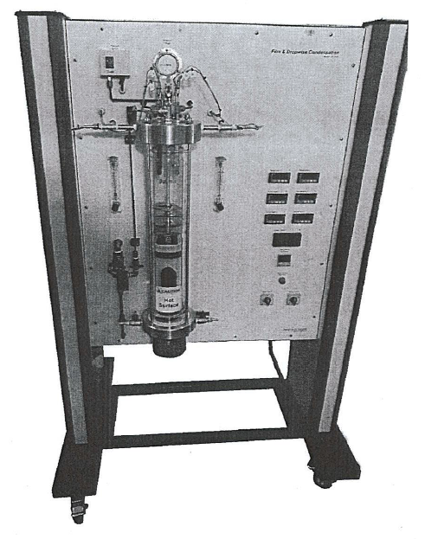
Figure 3-1: Experimental Setup

3.4 Theory

3.4.1 Condensation
Condensation of a vapor to a liquid and vaporization of a liquid to a vapor both involve a change of phase of a fluid with large heat-transfer coefficients. Condensation occurs when a saturated vapor such as steam comes in contact with a solid whose surface temperature is below the saturation temperature, to form a liquid such as water.
Normally, when a vapor condenses on a surface such as a vertical or horizontal tube or other surface, a film of condensate is formed on the surface and flows over the surface by the action of gravity. It is this film of liquid between the surface and the vapor that forms the main resistance to heat-transfer. This is called film wise condensation.
Another type of condensation, dropwise condensation, can occur, where small drops are formed on the surface. These drops grow and coalesce, and the liquid flows from the surface. During this condensation, large areas of tube are devoid of any liquid and are exposed directly to the vapor. Very high rates of heat-transfer occur on these bare areas. The average coefficient can be as high as 110 000 W/m² ·K (20 000 btu/h.ft²·°F), which is five to 10 times larger than film-type coefficients. Film-condensation coefficients are normally much greater than those in forced convection and are on the order of magnitude of several thousand W/m² .K or more.

3.4.2 Film Wise Condensation
Unless specially treated, most materials are wetting and as condensation occurs a film of condensate spreads over the surface. The thickness of the film depends upon a number of factors such as (1) the rate of condensation, (2) the viscosity if the condensate and (3) orientation of condensing surface, whether vertical, horizontal or inclined. As fresh vapor condenses on top of film, the heat of condensation has to pass by conduction through the film to the metal surface beneath .As the film thickness; it flows downward and drips from the low points leaving the film intact and at an equilibrium thickness.
Film-Condensation coefficients for vertical surfaces
Film-type condensation on a vertical wall or tube can be analyzed analytically by assuming laminar flow of the condensate film down the wall. The film thickness is zero at the top of the wall or tube and increases in thickness as it flows downward because of condensation. Nusselt (Hl, Wl) assumed that the heat transfer from the condensing vapor at T sat K, through this liquid film, and to the wall at Tw K was by conduction. Equating this heat-transfer by conduction to that from condensation of the vapor, a final expression can be obtained for the average heat-transfer coefficient over the whole surface.
The recommended expression for vertical surfaces in laminar flow is:
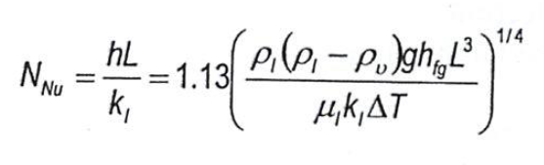
where p, is the density of liquid in kg/m3 and p_{v} that of the vapor, g is 9.8066 m/s2, L is the vertical height of the surface or tube in m, µ, is the viscosity of liquid in Pa ·s, k1 is the liquid thermal conductivity in W/m ·K, ΔT = T_{sat} - T_{w} in K, and h_{fg} is the latent heat of condensation in J/kg at T_{sat}. All physical properties of the liquid except h_{fg} are evaluated at the film temperature T_{f} = (T_{sat} + T_{w})/2.

3.4.3 Dropwise Condensation
When the condensate does not wet the surface, it forms the droplets on the surface, it is known as “dropwise condensation”. When the surface tension is large, the condensate coalesces into a multitude of droplets of different sizes. With time, each droplet grows as more vapor condenses on its exposed surface. The formation of each droplet is initiated at a point of surface imperfection (pit, scratch, etc.) and such sites are called “nucleation sites”. At some time, the tangential pull of gravity, or sheer force exerted by the vapor stream, dislodges the droplet and carries it downstream. The moving droplet devours the smaller droplets in its path, thereby creating a clean trail ready for the generation of new droplets of smaller sizes. This surface renewal process occurs periodically as the droplets accumulate and grow in size. Since the condensation rate is the highest in the absence of condensate on the surface, the periodic cleaning performed by the large drops renews finite size regions of the surface for the restart of the condensation. This surface renewal process is the main reason why dropwise condensation is a highly effective heat transfer mechanism. The heat transfer coefficient is roughly ten times greater than the corresponding condensation in the form of thin film. In the design of condensers, whose function is to cool a vapor stream and to convert it into liquid, there is a great advantage to promote the breakup of the condensate into droplets. This can be achieved by:
- Coating the solid surface with an organic substance like wax, oil, oleic acid, etc.
- Injecting non-wetting chemicals into the vapor, which get deposited on the surface of the condenser.
- Coating the surface with a polymer of low surface energy like Teflon, silicone, etc. or with a noble metal like gold, silver, etc.
The mechanism of dropwise condensation is complex because of its intermittent time dependent character, effect of surface tension (due to drop size and shape) and the uncertainty associated with the location of nucleation sites and the time when the largest droplet will start its downstream movement.

3.5 Procedure

3.5.1 General Operating Procedure
Temperature Selection
To read a particular temperature.
For film-wise
Tl = Surface temperature
T3 = Water in, Tin
T5 = Water out, Tout
For dropwise
T2 = Surface temperature
T4 = Water in, Tin
T6 = Water out, Tout
Cooling Water Flow Selection
Flow meters for film wise and drop wise condensers are connected separately on left and right side of heater.
Heater Setting
To tum on the heater, simply switch the heater switch to "ON" position. The power supply to the heater is controlled by regulator.
Cooling Water Control
The cooling water flowrate can be controlled by simply turning the valve clockwise to reduce flowrate and vice versa.

3.5.2 General Start Up Procedure
- Ensure that the main switch is in the off position.
- Tum the power regulator knobs fully anti-clockwise to set the power to mm1mum.
- Fill the chamber with distilled water until the water level stays between the heater and baffle plates. Always make sure that the heater is fully immersed in the water during throughout the experiment.
- Adjust the water flowrate to the condenser by controlling the control valve according to the experimental procedure.
- Tum on the main switch, follows by the heater switch. Set the heater power by rotating the power regulator clockwise to increase the heating power.
- Observe the water temperature reading; it should increase when the water started to heat-up.
- Let the system to stabilize then take all relevant measurements for experimental purposes. Make adjustment if required.

3.5.3 Procedure of Experiment
A. For film wise condensation
- Circulate the cooling water through the film wise condenser starting with the minimum value of 0.2 Liter/min.
- Adjust the heater to obtain the desired pressure at 1.01 bar.
- When the condition is stabilized, record the steam (Tsat) & surface temperature (Tsurf), Tin (T3) & Tout (T5), and flowrate.
B. For dropwise condensation
- Circulate the cooling water through the film wise condenser starting with the minimum value of 1 Liter/min.
- Adjust the heater to obtain the desired pressure at 1.01 bar.
- When the condition is stabilized, record the steam (Tsat) & surface temperature (Tsurf), Tin (T3) & Tout (T5), and flowrate.

3.6 Observation and Calculation
A. Film wise condensation
Φ = Heat Flux = [m C (T_{in} – T_{out}) ] / A_{surf}
h = Heat transfer Coefficient = Φ / (T_{sat} – T_{w})

Table 3-1: Observation Table for film wise condensation
Flow rate  (LPM) | m  (kg/s) | Power  (W) | Tin  (⁰C) | Tout  (⁰C) | Tsat  (⁰C) | Tsurf  (⁰C) | Tsat – Tsurf  (⁰C) | Φ  (W/m²) | h  (W/m².K)
Sample Calculations:

B. Dropwise condensation
Φ = Heat Flux = [m C (T_{sat} – T_{surf}) ] / A_{surf}
U = Average Heat transfer Coefficient = Φ / (T_{sat} – T_{w})

Table 3-2: Observation table of Dropwise condensation
Flow rate  (LPM) | m  (kg/s) | Power  (W) | Tin  (⁰C) | Tout  (⁰C) | Tsat  (⁰C) | Tsurf  (⁰C) | Tsat – Tsurf  (⁰C) | Φ  (W/m²) | h  (W/m².K)

Sample Calculations

3.7 Precaution
- Do not touch the glass surface during experimentation
- Never operate the heater whenever the water level falls below the heater element as this may cause a permanently damage to the heater
- Upon shutdown, keep the cooling water flowing for at least 5 minutes through the condensers to cold them down.

3.8 Result and Discussion
(Guidelines for this section is mentioned below)

3.8.1 Graphs
- Plot a heat flux vs. Temperature Difference with various flowrates for film wise condensation
- Plot a surface Heat Transfer Coefficient vs. Temperature Difference with various flowrates for film wise condensation
- Plot a heat flux vs. Temperature Difference with various flowrates for drop wise condensation
- Plot a surface Heat Transfer Coefficient vs. Temperature Difference with various flowrates for drop wise condensation

3.8.2 Points to be discussed
- The achieved order of magnitude of the heat transfer coefficient for condensation with respect convection or conduction
- The behavior of the plot of the heat flux and average heat transfer coefficient for film wise and dropwise condensation
- Comparison of the plots of average heat transfer coefficient for film wise condensation and dropwise condensation
- The possible sources of error in the experiment
- Recommendation for improvement in the experiment (if any)

EXPERIMENT 4
Date: ________________
ABSTRACT

(Abstract to be written in Times New Roman, 12, Justify)

Experiment 4
Study of heat transfer in free and forced convection

4.1 Learning Objectives
- Student will learn to measure heat transfer coefficient in case of both, free and forced convection
- They will observe the higher effectiveness of forced convection in transferring heat in comparison to free convection
- The effect of speed of fluid on the heat transfer coefficient of forced convection will also be studied

4.2 Introduction
Convection is the transfer of heat by the movement of a fluid (liquid or gas) between areas of different temperature. Warm air is less dense than cold air, and so convection currents can form in the presence of a temperature gradient. When currents are produced only by temperature-derived density differences in the fluid, it is known as natural convection. When the convection currents are due to an external factor such as a pump or fan, this is forced convection. The faster the fluid is moved, the faster the rate of convection.
The exchange of heat by convection between a body and its environment depends on:
- The temperature gradient between the two (this determines the amount of heat absorbed or donated by a given mass of air that comes into contact with the surface).
- Relative movement of the fluid with which the body is in contact.
Convection occurs in liquids and gases. For any solid to lose or gain heat by convection it must be in contact with the fluid. Convection cannot occur in a vacuum.
Heat transfer by simultaneous conduction and convection, whether free or forced, forms the basis of most industrial heat exchangers and related equipment.
The measurement and prediction of heat transfer coefficients for such circumstances is achieved in this experiment by studying the temperature profiles and heat flux in an air duct with associated flat transfer surface.

4.3 Experimental Setup
Model: EES-TH-3104
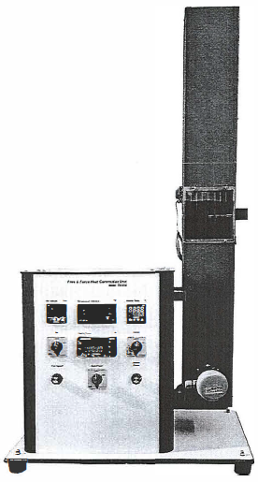
Figure 4-1: Experimental Setup
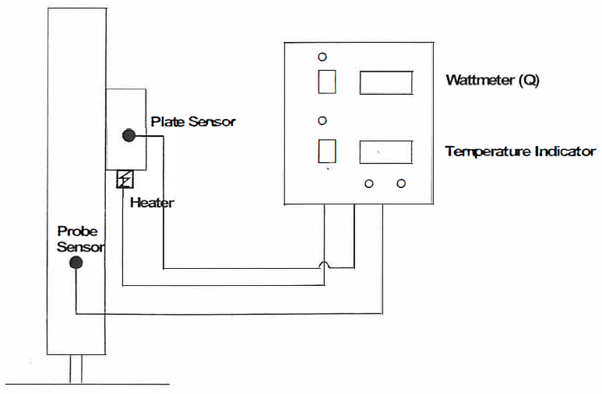
Figure 4-2: Schematic of Experimental Setup

4.4 Theory

4.4.1 Free Convection
A heated surface dissipates heat primarily through a process called convection. Heat is also dissipated by conduction and radiation, however these effects are not considered in this experiment. Air in contact with the bot surface is heated by the surface and rises due to a reduction in density. The heated air is replaced by cooler air which is in turn heated by the surface and rises. This process is called free convection.
The hotter the temperature of the surface, the greater the convective currents and more beat (power) will be dissipated. If more power is supplied to a surface, the temperature of the surface must rise to dissipate this power.
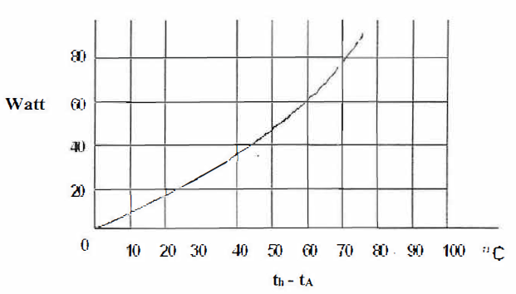
Figure 4-3: Typical graph of power against surface temperature

4.4.2 Forced Convection
In free convection the heat transfer rate from the surface is limited by the small movements of air generated by this heat. More heat is transferred if the air velocity is increased over the heated surface. This process of assisting the movement of air over the heated surface is called Forced Convection. Therefore a heated surface experiencing forced convection will have a lower surface temperature than that of the same surface in free convection, for the same power input.
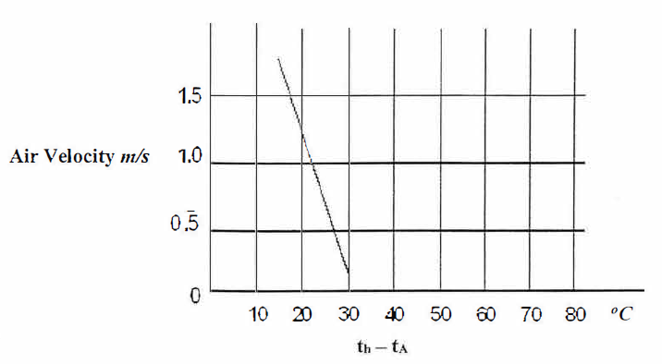
Figure 4-4: Typical graph of air velocity against surface temperature

4.5 Procedure

4.5.1 General Start-up Procedure:
- Connect the mains input power supply plug to a nearest single-phase electrical supply of 220V AC/50Hz.
- Turn the heater power control knob and fan speed control knob fully anti­clockwise.
- Clamp the flat plate beat exchanger into the duct using the two toggle clamps and connect the heater power supply lead and temperature controller lead with the control box.
- Ensure that the sensor hole is aligned with the direction of the airflow when inserting the probe through the wall of the duct.
- Switch on the main power.
- Check that the L.E.D. meter as they are illuminated. Check that the temperature meter indicates temperatures.
- Increase the heater power in the exchanger by rotating the power control knob clockwise. The power supplied to the exchanger should be shown in watts on the meter.
- Switch on the fan and increase the speed by rotating the fan speed control knob clockwise.
- Observe that the air velocity is indicated on the indicator.
- Check that the plate temperature (TH) increases.
- Set the heater power control and fan speed control knob to minimum.
- Now you are ready for the following experiments.

4.5.2 Procedure of Experiment
A. Free Convection
- Place the heat exchanger into the test duct.
- Set up the plate heat exchanger
- Set the heater power control to 20 Watts (clockwise).
- Allow sufficient time to achieve steady state conditions before noting the heated plate temperature (TH) and ambient temperature (TA) into the table below.
- Repeat this procedure at 40, 60 and 80 Watts.
B. Forced Convection
- Place the heat exchanger into the test duct.
- Set up the plate heat exchanger
- Set the heater power control to 50 Watts (clockwise). Allow sufficient time to achieve steady state conditions before noting the heated plate temperature (TH) and the ambient temperature (TA)-
- Set the fan speed control to give a reading of 0.5m/s on the thermal anemometer, allow sufficient time to achieve steady state conditions. Record heated plate temperature (TH) and ambient temperature (TA).
- Repeat this procedure at 40, 60 and 80 Watts.
C. Forced convection with varying air speed
- Place the heat exchanger into the test duct.
- Set up the plate heat exchanger
- Set the heater power control to 50 Watts (clockwise). Allow sufficient time to achieve steady state conditions before noting the heated plate temperature (TH) and the ambient temperature (TA)
- Set the fan speed control to give a reading of 0.5 m/s on the thermal anemometer, allow sufficient time to achieve steady state conditions. Record heated plate temperature (TH) and ambient temperature (TA).
- Repeat this procedure by setting the fan speed control to give 10 m/s and 1.5 m/s and onwards.

4.6 Observation and Calculations
A. Free Convection
Area= A = _____________
Table 4-1: Observation table for free convection
Input Power  (W) | Plate Temperature (T_{H})  (⁰C) | Ambient Temperature (T_{A})  (⁰C) | T_{H} – T_{A}  (⁰C) | Heat transfer Coefficient, h  W/m². K

Sample Calculation:

B. Forced Convection
Area= A = _____________
Table 4-2: Observation table for forced convection
Input Power  (W) | Plate Temperature (T_{H})  (⁰C) | Ambient Temperature (T_{A})  (⁰C) | T_{H} – T_{A}  (⁰C) | Heat transfer Coefficient, h  W/m². K

Sample Calculations:

C. Forced convection with varying air speed
Area= A = _____________
Table 4-3: Observation table for forced convection with varying speed
Air Velocity  m/s | Plate Temperature (T_{H})  (⁰C) | Ambient Temperature (T_{A})  (⁰C) | T_{H} – T_{A}  (⁰C) | Heat transfer Coefficient, h  W/m². K
Sample Calculations:

Result and Discussion
(Guidelines for this section is mentioned below)

4.7.1 Data Analysis
- Organize your lab data and calculated values in a neat spreadsheet array. Use only the SI system of units
- Plot a graph of power against temperature (T_{H} - T_{A}) for both free and forced convection case on single graph
- Plot a graph between air velocity against temperature (T_{H} – T_{A})

4.7.2 Points to be discussed
- The trend of the plot between input power and T_{H} - T_{A} for both free and forced convection
- Comparison of the heat transfer in free and forced convection
- The behavior of the curve plotted between air velocity and the temperature T_{H} - T_{A}
- Possible sources of error
- Recommendations for improvement in experiment (if any)

EXPERIMENT 5
Date: ________________
ABSTRACT

(Abstract to be written in Times New Roman, 12, Justify)

Experiment 5
Study of the heat transfer through extended surfaces

5.1 Learning Objectives
- To understand the effect of extended surfaces on the heat transfer by convection
- Compare the heat transfer from flat, pinned and finned surfaces
- Determination of the temperature distribution along the external surface (finned)

5.2 Introduction
In the study of heat transfer, fins are surfaces that extend from an object to increase the rate of heat transfer to or from the environment by increasing convection. The amount of conduction, convection, or radiation of an object determines the amount of heat it transfers. Increasing the temperature gradient between the object and the environment, increasing the convection heat transfer coefficient, or increasing the surface area of the object increases the heat transfer. Sometimes it is not feasible or economical to change the first two options. Thus, adding a fin to an object, increases the surface area and can sometimes be an economical solution to heat transfer problems.
Fins are most commonly used in heat exchanging devices such as radiators in cars, computer CPU heatsinks, and heat exchangers in power plants. They are also used in newer technology such as hydrogen fuel cells. Nature has also taken advantage of the phenomena of fins. The ears of jackrabbits and fennec foxes act as fins to release heat from the blood that flows through them.

5.3 Experimental Setup
Model: EES-TH-3104
Figure 5-1: Experimental setup

5.4 Theory

5.4.1 Extended Surfaces
Heat transfer from an object can be improved by increasing the surface area in contact with the air. In practice it may be difficult to increase the size of the body to suit. In these circumstances the surface area in contact with the air may be increased by adding fins or pins normal to the surface. These features are called extended surfaces. A typical example is the use of fins on the cylinder and bead of an air cooled petrol engine. The effect of extended surfaces can be demonstrated by comparing finned and pinned surfaces with a flat plate under the same conditions of power input and airflow.
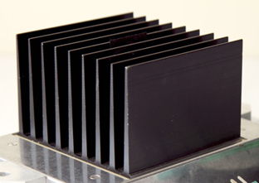
Figure 5-2: Plate-type fin
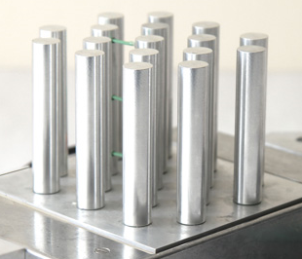
Figure 5-3: Pin-type fin
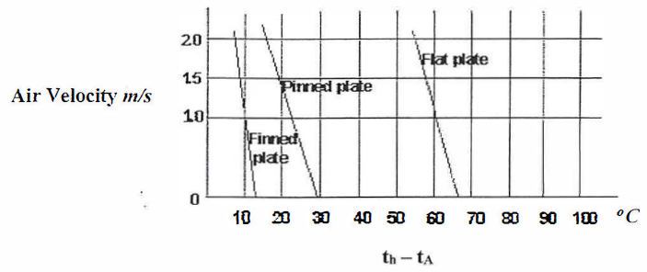
Figure 5-4: Typical graph of air velocities against surface temperature

5.4.2 Temperature Distribution along an Extended Surface
For a heat exchanger to be 100% efficient, the whole of the extended surface must be at the same temperature as the backplane. In practice, this cannot occur because the flow of heat along the pins or fins by conduction causes a temperature gradient to occur. The greater this gradient, the less efficient the heat exchanger will be.
The efficiency of the heat exchanger must not be confused with the effect of a change in surface area e.g. comparing pinned and finned. For example, if the pinned and finned heat exchangers supplied with the equipment are compared, the pin is more efficient than the fin (slightly smaller temperature gradient) but the finned exchanger has a significantly larger surface area than the pinned exchanger and can dissipate more heat for the same surface temperature.
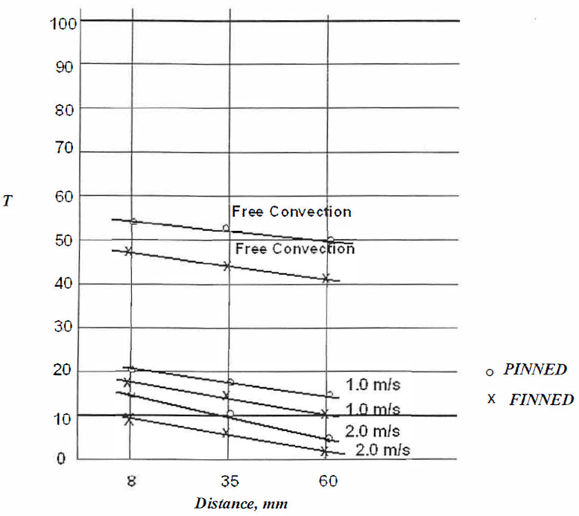
Figure 5-5: Graph of surface temperature against distance from back plate

5.5 Procedure
A. Effect of extended surfaces
- Place the heat exchanger into the duct.
- Set up the heat exchanger
- Set the heater power control to 75 Watts. Allow the temperature to rise to 80°C, and then adjust the heater power control to 15 Watts until a steady reading is obtained.
- Set the fan speed control to give l m/s using the thermal anemometer. Record heated plate temperature (TH) and the ambient temperature (TA).
- Repeat this procedure at 2 and 2.5 m/s for the flat plate. Repeat the experiment by replacing the flat plate with the finned plate and pinned plate.

B. Temperature Distribution along an External Surface
- Measure from the back plate the distance of the three access holes on the pinned and finned heat exchangers.
- Set up the heat exchanger
- Set the heater power control to 60 watts. Allow sufficient time to achieve steady state conditions before noting the heated plate temperature (T_{H}) and the ambient temperature (T_{A}).
- Insert the temperature probe into the duct through the hole nearest the heated plate ensuring that the tip of the probe is in contact with the pin. A small amount of heat conducting compound on the tip will ensure a good thermal contact. Note this temperature (Tl).
- Record the pin temperatures (T2 and T3) using the remaining two holes. Repeat this procedure at 1.0 m/s and 2 m/s and so on.
- Remove the pinned heat exchanger and replace with the finned heat exchanger. Repeat complete experiment.

5.6 Observation and Calculations
A. Effect of extended surfaces
Table 5-1: Observation table for extended surfaces
Velocity  (m/s) | Plate Temperature  (⁰C) |  |  | Ambient Temperature  (⁰C) | TH – TA  (⁰C)
 | Flat Plate | Pinned | Finned |  | Flat Plate | Pinned | Finned
Sample Calculations:

B. Temperature Distribution along an External Surface
Power input = __________ watts
Distance nearest hole = 21 mm
Distance from middle hole = 69 mm
Distance from farthest hole = 117 mm
Table 5-2: Observation table for temperature distribution
Air velocity  (m/s) | Temperature, (⁰C)
 | t1 |  | t2 |  | t3 |  | t4
 | Pinned | Finned | Pinned | Finned | Pinned | Finned | Pinned | Finned

Sample Calculations:

5.8 Result and Discussion
(Guidelines for this section is mentioned below)

5.8.1 Data Analysis
- Plot a graph between air velocities against TH – TA for flat plat, pinned and finned surface simultaneously
- Plot a graph of surface temperature against distance from back plate for the two heat exchangers at various air velocities

5.8.2 Points to be discussed
- The effect of adding extended surface to the plate on the heat transfer
- Comment on the correlation between total surface area of the heat exchanger and the temperature achieved
- Compare the plots of temperature difference of surface with T_{a} for flat, pinned and finned surfaces
- Discuss the profile of temperate on the extended surface for both pinned and finned surface
- Form plot confirm the more efficient behavior of pinned surface than a finned one for same cross section

EXPERIMENT 6
Date: ________________
ABSTRACT

(Abstract to be written in Times New Roman, 12, Justify)

Experiment 6
Study of Radiation Heat Transfer

6.1 Learning Objectives
- To understand different laws related to radiation heat transfer
- To observe the validation inverse square law
- To observe the validation of Stefan-Boltzmann law

6.2 Introduction
Thermal radiation is a mode of heat transfer, which differs significantly from the other two modes, namely conduction and convection. The fact that radiant energy transfer occurs across a vacuum is often disturbing to students unless the theory relating to properties of electromagnetic waves has been presented.
The engineer is not directly concerned with the mechanism by which heat transfer occurs, sound knowledge of the properties and laws relating to the topic are required.
Inverse Square Law for Heat – It states that, the intensity of radiation on a surface is inversely proportional to the square of the distance of the surface from the radiation source.
Stefan-Boltzmann Law – It states that, the intensity of radiation varies as the fourth power of the source temperature.
Kirchhoff’s Law - which states that the emissivity of a grey surface is equal to its absorptivity of radiation received from another surface when in a condition of thermal equilibrium.
Area Factors – It states that the exchange of radiant energy from one surface to another is dependent upon their interconnecting geometry, i.e. a function of the amount that each surface can 'see' of the other.

6.3 Experimental Setup
Setup name: Radiation Heat transfer Apparatus
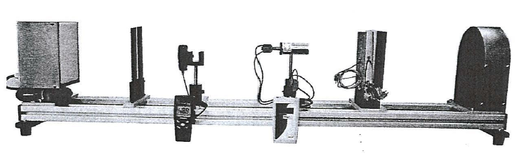
Figure 6-1: Radiation heat transfer Apparatus
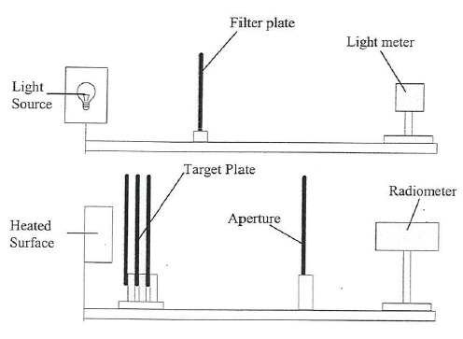
Figure 6-2: Schematic of Apparatus

6.4 Theory

6.4.1 Inverse Square Law for Heat
The total energy dQ from an element dA can be imagined to flow through a hemisphere of radius r. A surface element on this hemisphere dA₁ lies on a line making an angle φ with the normal and the solid angle subtended by dA I at dA is dφ₁= dA₁/r².
(NOTE: solid angle which is by definition the intercepted area on a sphere divided by r².)
If the rate of flow of energy through dA₁ is dQ₁ then dQ₁= i_{φ} dφ₁ dA where i_{φ} is the intensity of radiation in the φ direction. i.e. dQ₁ α 1/ r2
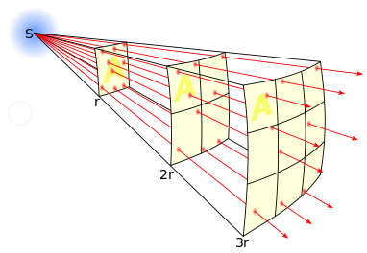
Figure 6-3: Inverse square law

6.4.2 Stefan-Boltzmann Law
The Stefan-Boltzmann Law states that: q_{b}= σ (T_{s}⁴-T_{a}⁴)
Where:
q_{b} = energy emitted by unit area of a black body surface (Wm⁻²)
(Note: Energy emitted by surface = 3.040 x Reading from radiometer R-refer to Radiometer Data Sheet for explanation)
σ = Stefan-Boltzmann constant equal to 5.67 x 10⁻⁸ (Wm⁻² K⁻⁴)
T_{s}= Source temperature and surrounding (K)
T_{a}= Temperature of radiometer and surroundings (K)

6.5 Procedure

6.5.1 General Start up Procedure
- Ensure that the main switches of the Heat Transfer Apparatus is off.
- Install the radiometer on the horizontal track. The complete installation is shown in Figure 1.
- Connect the heater supply cable to the power output socket of the control box.
- Connect the radiometer cable to the data logger.
- Connect the thermocouples of the heater assembly (TH) and three target plates (TB, TG and Tr) to the control box. Then switch on the control box.
- Check the thermocouple reading from the plate should indicate ambient temperature.
- Check the radiometer on the panel indicates zero.
- Supply power to the heater, TH temperature and the radiometer reading should increase.
- As the surface temperature of the heat source increases, observe the readouts of radiation. The reading should increase.

Procedure of Experiment
- Inverse Square Law for Heat
- Connect one of the thermocouples of the target plates say TP, to the control box and place the plate on the bench, to record ambient temperature.
- Position the radiometer on the test track at 800 mm from the heat source.
- Switch on the power to the heaters using switch on the control box.
- Monitor TH reading on the control box.
- When TH value has stabilized or reached to controlled temperature, record TB, TH, the distance 'x', and the radiometer reading 'R'.
- Next, move the radiometer position to 700 mm from the heated surface and monitor the reading on the display panel. When the value has stabilized, record Tp, T_{H}, the distance 'x', and the radiometer reading 'R'.
- Repeat the above procedure by reducing the distance by 100 mm until the radiometer is 300 mm from the heated surface.
- Stefan-Boltzmann Law
- Connect one of the thermocouple of the target plates T p to the Control box and place the plate on the bench, to record ambient temperature.
- Position the radiometer on the test track at 800 mm from the beat source.
- Switch on the power to the beaters using the switch on the control box.
- Monitor TH reading on control box.
- When TH value has stabilized or reached to controlled temperature, move the radiometer to 300 mm from the heated plate. The reading of the radiometer should start to rise. When the value has stabilized, record Tp, TH, the distance 'x', and the radiometer reading, 'R'.
- Next, move the radiometer to 800 mm from the heated plate again.
- Repeat the above procedure with an increment of temperatures from PID controller.

6.6 Observation and Calculations
A. Inverse Square Law for Heat

Table 6-1: Observation table for Inverse square law
Distance, x (mm) | Radiometer Reading, R (W/m²) | T_{P} (⁰C) | T_{H} (⁰C)
800
700
600
500
400
300

B. Stefan-Boltzmann Law

Table 6-2: Observation Table for Stefan-Boltzmann Law
Temperature, T  (⁰C) | Distance,  x (mm) | Radiometer Reading, R  (W/m²) | T_{P} (⁰C) | T_{H} (⁰C)

6.7 Precautions
- DO NOT touch the heater plate while it is hot.
- Leave the equipment for a sufficient time to cold down the beater plate after switching off the heater.
- When assemble the target plates, make sure that the bolt-on thermocouple is facing the heated surface.

6.8 Result and Discussion
(Guidelines for this section is mentioned below)

6.8.1 Data Analysis
- Plot the Log of the radiometer reading R versus Log(x) graph and calculate the slope. Compare the result with the theoretical values from Inverse Square Law experiment
- Plot the amount of radiations in W/m² observed from radiometer versus distance and compare it with the expected plot of radiation values from Stephan Boltzmann.
- Plot a graph of surface temperature against distance from back plate for the two heat exchangers at various air velocities

6.8.2 Points to be discussed
- Comparison of the results of experiments of inverse square law with theoretical results
- Comparison of the results of experiments of Stefan-Boltzmann Law with theoretical results
- Possible errors in the readings

EXPERIMENT 7
Date: ________________
ABSTRACT

(Abstract to be written in Times New Roman, 12, Justify)

Experiment 7
Performance Study of Vapor Compression System (Forward Cycle)

7.1 Learning Objectives
- To revise the basic theory of vapor compression system.
- To understand the operation of basic components of vapor compression system
- To determine the performance of vapor compression system with different expansion devices.

7.2 List of Equipment
- EES EM-872 Refrigeration Technology Demonstration Module

7.3 Introduction
(To be written by students in Times New Roman, 12.)

7.4 Theory
Refrigeration may be defined as lowering the temperature of an enclosed space by removing heat from that space and transferring it elsewhere. The refrigeration process is carried out by a device called a refrigerator. So a refrigerator is a device that extracts heat from a low temperature reservoir and delivers to high temperature reservoir. All the practical refrigerators work on some fundamental thermodynamic cycle also called refrigeration cycle. The refrigeration cycles may be broadly classified into two main categories,
- Gas based refrigeration cycles
- Vapor based refrigeration cycles
In gas-based refrigeration cycles the working fluid also called refrigerant remains in gaseous state throughout the execution of cycle and there is no change of phase at any point in the cycle. The example of gas-based refrigeration cycles is air refrigeration cycles that are employed in air conditioning of air crafts.
In vapor-based refrigeration systems, the working fluid (refrigerant) evaporates and condenses during the execution of cycle. The vapor-based refrigeration cycles can then be further classified into two subcategories,
- Vapor absorption refrigeration cycle
- Vapor compression refrigeration cycle
The fundamental difference between absorption and compression cycle is that absorption cycle uses heat as a source of energy while compression cycle uses mechanical work as the fundamental source of energy. This mechanical work is provided by compressor.
Vapor compression refrigeration system is the most widely used method for air-conditioning of buildings and automobiles. It is also used in domestic and commercial refrigerators, large-scale warehouses for chilled or frozen storage of foods and meats, refrigerated trucks and railroad cars, and a host of other commercial and industrial services. Oil refineries, petrochemical and chemical processing plants, and natural gas processing plants are among the many types of industrial plants that often utilize large vapor-compression refrigeration systems.

7.4.1 Refrigerants
A refrigerant is a medium that flows in refrigeration circuit and carries heat from low temperature reservoir to high temperature reservoir. The refrigerants are broadly classified into two major categories,
- Primary refrigerants
- Secondary refrigerants

The primary refrigerant is that directly take part in the refrigeration of target space while secondary refrigerant are those which are first cooled by primary refrigerant and then they are used to cool the target space. The examples of primary refrigerants classified into four categories,
- Halo-carbon refrigerants
- Azeotropic refrigerates
- Inorganic refrigerants
- Hydro carbon refrigerants.

Halocarbons are a family of manufactured molecules consisting of hydrogen, carbon, fluorine, chlorine, and/or bromine. The history of halocarbons, sometimes known as CFCs and Halons, is tied to the development of refrigeration. The examples of Halocarbons include,
- R-11 (CCl₃F)
- R-12 (CCl₂F₂)
- R-113 (C₂Cl₃F₃)
- R-134a (CF₃CH₂F) etc.
Azeotropic refrigerants are mixtures of refrigerants whose vapor and liquid phase maintain identical composition over a wide range of temperature. The examples include
- R-500 = 73.8% R-12 (CCl₂F₂) + 26.2% R-152 (CH₃CHF₂)
- R-502 = 48.8% R-22 (CHClF₂) + 51.2% R-115 (CClF₂CF₃)
Inorganic refrigerants have been used even before the development of Halocarbons and are still in use due to their thermodynamic and physical properties. The examples include,
- R-717 = NH₃
- R-729 = Air
- R-118 = H₂O
- R-744 = CO₂
Hydrocarbon refrigerant have been used in industrial and commercial application but the major disadvantage is that they are highly inflammable and explosive. Due to these disadvantages they are almost obsolete. The example includes,
- R-170 = C₂H₆
- R-1120 = C₂H₄Cl₃
- R-1270 = C₃H₆

7.4.2 Basic Components of Simple Vapor Compression Cycle
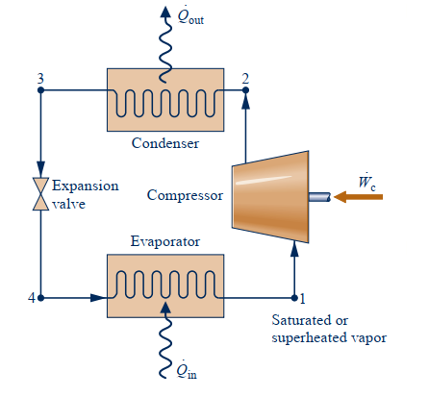
Figure 7-1: A schematic diagram of simple vapor compression system
Vapor compression cycle based refrigeration system includes following four basic components.
- Evaporator
- Compressor
- Condenser
- Expansion device
A simple vapor compression cycle based refrigeration system is shown in following figure, and the function of each component is explained in coming section.
It must be noted that, depending upon the pressure of refrigerant, the vapor compression system can be divided into,
- High pressure side
- Low pressure side
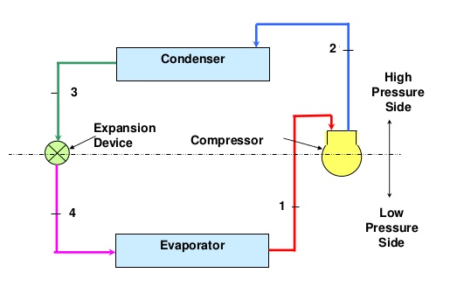
Figure 7-2: Distinction between low pressure side and high pressure side
The low pressure side, as shown in figure basically consists of three components
- The refrigerant line connecting expansion device and evaporator
- The evaporator
- The suction line i.e. line between evaporator and compressor
On the other hand the high pressure side consists of,
- The compressor
- The discharge/delivery line (line connecting the compressor exit and condenser inlet)
- The condenser
- Liquid line (refrigerant line connecting condenser exit and expansion device inlet)
The following section explains the function of basic components of standard vapor compression system.

7.4.2.1 Evaporator
Evaporator is a heat exchanger where a low temperature low pressure refrigerant flowing in tubes absorbs heat from the target space. At the entry of evaporator, the refrigerant is coming from expansion device and is characterized as two phase mixture of saturated liquid and saturated vapors. The mixture is of low pressure and low temperature with low dryness fraction. The most of the heat is absorbed by saturated liquid refrigerant is latent heat of vaporization and then itself transforms into saturated vapors. The already existing vapors in refrigerant tubes also absorb sensible heat but the share of sensible heat transfer is negligible. In standard cycle analysis at the exit of evaporator it is assumed that saturated vapors are available to be delivered to the compressor. Although in real case, a slight superheating is recommended before entering into compressor as it ensures that no liquid droplets enter the compressor as the droplets may cause pitting of compressor material during compression process. On the other hand superheating also increases the work of compressor so a tradeoff is needed between the economy of operation and life of compressor.

7.4.2.2 Compressor
Compressor acts as the sole component of vapor compression refrigeration system. The compressor basically serves two main functions,
- It serves the requirement of second law of thermodynamics i.e. it delivers work input to the cycle so that heat may be transferred from low temperature space to high temperature surrounding environment.
- It acts to provide the continuation to the cycle of refrigeration system.
The low temperature-low pressure saturated vapors coming from the evaporator are compressed and transformed into high pressure-high temperature superheated vapors. At this condition they are able to deliver heat to ambient environment.

7.4.2.3 Condenser
Condenser is a heat exchanger in which high temperature high pressure (Superheated refrigerant) coming from compressor condenses into liquid phase. In standard vapor compression cycle we shall assume that at the exit of condenser, the refrigerant at the exit of condenser is saturated liquid with the pressure same as the compressors exit pressure. In most of domestic and commercial applications the condensers are air cooled and in most of industrial applications the condensers are water cooled. In fact the selection of type of condenser depends on capacity of refrigeration system, type of refrigerant used and type of cooling medium used.

7.4.2.4 Expansion Device
Expansion device also called throttling device separated the high pressure and low pressure sides of the system. The functions of expansion device can be summarized as following,
- It reduces the pressure and temperature of refrigerant before being fed into evaporator.
- It maintains the pressure difference between high and low pressure sides.
- It controls the flow rate of refrigerant into the evaporator.
Following are types of expansion devices used in refrigeration systems,
- Capillary tube
- Hand operated expansion valve
- Automatic expansion valve
- Thermostatic expansion valve
- Float valves
As the apparatus being used consists of capillary tube and Thermostatic expansion valve, only these two devices will be discussed.

7.4.2.5 Capillary Tube
Capillary tube is used in small capacity refrigeration units such as refrigerators, water coolers, room air conditioners etc. It is basically a copper tube of small internal diameter of varying length. The inside diameter of capillary tube used in refrigeration applications is generally about 0.5 mm to 2.25 mm. It is installed between in liquid line between condenser and evaporator. A sample capillary tube is shown in following fig.
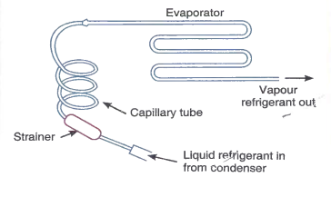
Figure 7-3: A capillary tube
A fine mesh screen is often provided at the inlet of the tube in order to protect it from containment. The expansion process depends upon the geometrical factors of the tube i.e. length (L) and diameter (D). The pressure drop is directly proportional to length and inversely proportional to the diameter of the tube. So longer the tube and smaller the diameter, higher will be the pressure drop inside the capillary tube.

7.4.2.6 Thermostatic Expansion Valve
Thermostatic expansion valve also called superheat controlled expansion valve because the actuation of valve is controlled by the superheat of refrigerant leaving the evaporator. A Thermostatic expansion valve is shown in following fig.
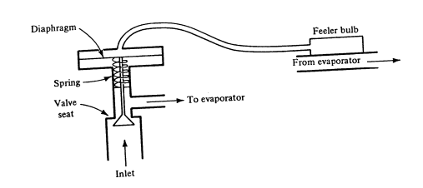
Figure 7-4: Schematic diagram of thermostatic expansion valve
Thermostatic expansion valve consists of a feeler bulb attached with the refrigerant line coming out of evaporator. This feeler bulb is a hollow from inside and is connected with diaphragm of valve body with the help of a small diameter tube. The feeler bulb cavity and the tube is filled with same refrigerant that circulates in refrigeration circuit. The opening and closing of spring operated valve is controlled by evaporation and ultimately superheating of refrigerant inside the evaporator. When the evaporator is subjected to higher heat loads the refrigerant becomes superheated and this superheated refrigerant at the exit of refrigerant makes the refrigerant in feeler bulb superheated due to heat transfer. The increased pressure inside the bulb and connecting tube allows the diaphragm to give wider opening to spring operated valve thus allowing more refrigerant to enter in the evaporator. Hence with the high heat loads in evaporator, the thermostatic expansion valve increases the flow rate of refrigerant entering the evaporator. Contrary to that when heat load and evaporator is decreased the reverse phenomenon occurs, and the pressure on the diaphragm decreases thus decreasing the refrigerant flow rate to the evaporator.

7.4.3 Thermodynamic Cycle and Property Diagrams
A standard vapor compression system along with its T-s diagram cycle is shown in following figure, It consists of four thermodynamic processes, i.e.,
1-2 Isentropic compression in compressor
2-3 Isobaric heat rejection/compression in compressor
3-4 Isenthalpic expansion in expansion device
4-1 Isobaric heat addition/expansion in evaporator.

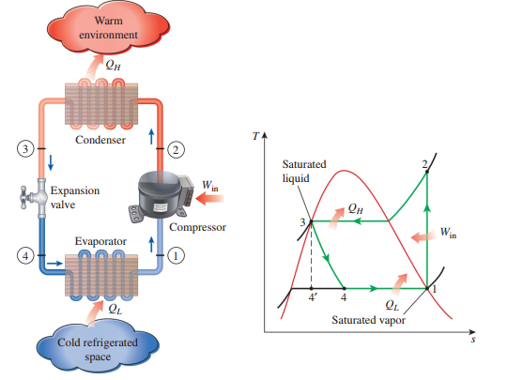
Figure 7-5: Standard vapor compression system and T-s diagram of cyle
The process 3-4’ is isentropic expansion process that occurs if the expansion takes place for instance in nozzle or turbine. Keeping in view the low temperature ranges of the system the installation of turbine in not feasible and also installation of nozzle is not recommended as higher velocity may result in higher pressure drops. Therefore the expansion process takes place in expansion devices such as capillary tubes or expansion valves. The expansion process therefore is highly irreversible but thermodynamically isenthalpic.

7.4.4 Performance of Vapor Compression System
The performance of vapor compression system is measured in terms of a dimensionless quantity called coefficient of performance (COP). The COP is basically a ratio of heat absorbed in evaporator (Q_{E}) to the work input by the compressor (W_{C}).
$$COP= \frac{Q_{E}}{W_{C}}= \frac{q_{e}}{w_{c}}= \frac{\dot{Q_{E}}}{\dot{W_{C}}}= \frac{Q_{L}}{W_{in}}$$
The process of vapor compression cycle as shown in above figure can also be produced on pressure-enthalpy (P-h) diagram of refrigerant. For the diagram shown above the P-h is shown in following figure.
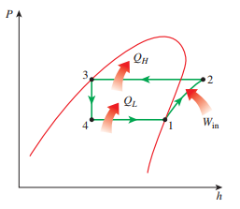
Figure 7-6: P-h diagram of a vapor compression cycle
From the P-h diagram, the expression of COP can also be written as following,
$$COP= \frac{h_{1}-h_{4}}{h_{2}-h_{1}}$$

7.5 Experimental Setup
The apparatus is EES EM-872 Refrigeration Technology Demonstration module with facility of three capillary tubes of same diameter but different lengths and a thermostatic expansion valve. The apparatus is shown in following figure and the nomenclature of components is given in next table.
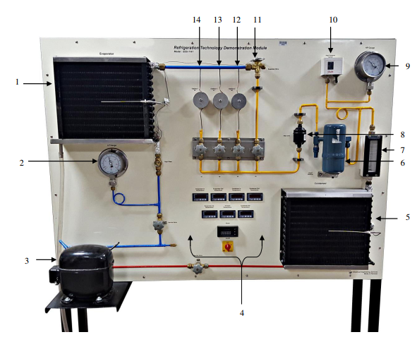
Figure 7-7: EM-872 refrigeration technology demonstration module
The aim of the experiments will be finding the performance indicator (COP) for four trials of experiments and then to determine how change in length of capillary tubes effects the COP of the system and how different is the COP of all these tubes from that of expansion valve under same operative conditions.

7.6 Experimental Procedure
(To be written by student in Times New Roman, 12. The procedure must be in form of points and provide precautions at the end. The contents of procedure and precautions must not be less than both sides of this page. Unnecessary spaces will lead to negative impression on award.)

7.7 Observations
Table 7-1: Observations for experiment 7
Sr.No | Throttling Device | High Pressure  (P_{H}) | Low Pressure  (P_{L}) | Evaporator Temperatures |  | Condenser  Temperatures |  | Power of Compressor  (${\dot{W}}_{C}$) | Condenser  Air Temperature | Evaporator  Air Temperature | Refrigerant volume flow rate
 |  |  |  | T_{E},in | T_{E},out | T_{C},in | T_{C},out
 |  | (Bar) | (Bar) | (^{O}C) | (^{O}C) | (^{O}C) | (^{O}C) | (watts) | (^{O}C) | (^{O}C) | (Ltr/hr)
1 | TX Valve
2 | Capillary (6m)
3 | Capillary (4m)
4 | Capillary (2m)

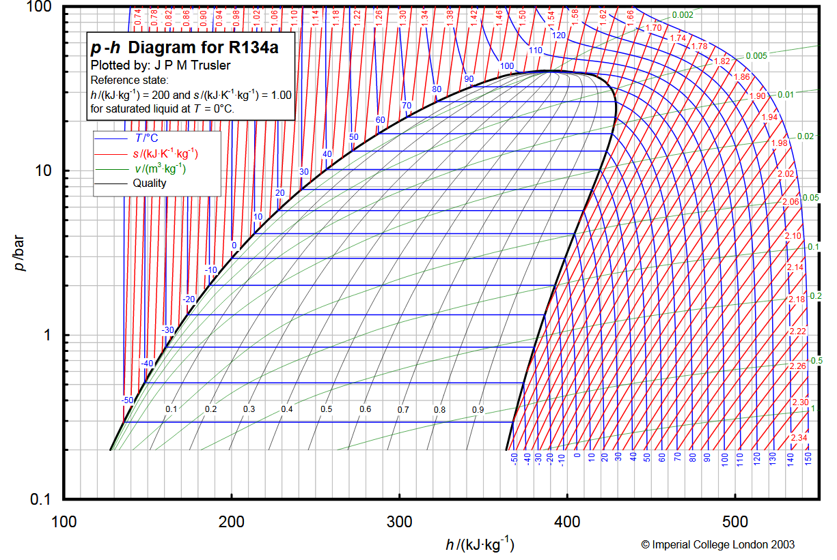
Figure 7-8: P-h diagram for thermostatic expansion valve
Figure 7-9: P-h diagram for capillary tube (6m)
Figure 7-10: P-h diagram for capillary tube (4m)
Figure 7-11: P-h diagram for capillary tube (2m)

7.8 Calculations
Table 7-2: Calculations for experiment 7
Sr.No | Throttling device | Mass flow rate |  | Compressor power | Refrigeration effect | Compressor work (from diagram) | COP _{actual} | COP _{p-h diagram}
 |  | Flow meter | Calculated
 |  | (Kg/sec) | (kg/sec) | (watts) | (watts) | (watts)
1 | TX Valve
2 | Capillary (6m)
3 | Capillary (4m)
4 | Capillary (2m)

7.9 Discussion and Conclusion
(Must be written by student in Times New Roman, 12. Also give conclusion at the end. The contents of discussion and conclusion must not be less than two sides of this page.)

EXPERIMENT 8
Date: ________________
ABSTRACT

(Abstract to be written in Times New Roman, 12, Justify)

Experiment 8
Performance Study of Vapor Compression System (Reversed Cycle)

8.1 Learning Objectives
- To revise the basic theory of heat pumps
- To understand the operation of basic components of a heat pump

8.2 List of Equipment
- TH-3135 Heat Pump air to water

8.3 Introduction
(To be written by students in Times New Roman, 12.)

8.4 Theory
Vapor compression refrigeration cycle when operated in reversed direction becomes a heat pump. Refrigerators and heat pumps are essentially the same devices; they differ in their objectives only. The objective of a refrigerator is to maintain the refrigerated space at a low temperature by removing heat from it. Discharging this heat to a higher-temperature medium is merely a necessary part of the operation, not the purpose. The objective of a heat pump, however, is to maintain a heated space at a high temperature. This is accomplished by absorbing heat from a low-temperature source, such as well water or cold outside air in winter, and supplying this heat to a warmer medium such as a house. The Fig shows the difference between a refrigerator and heat pump.
Most of the modern air conditioners based on vapor compression cycles are designed to work both in forward and reversed direction during summer and winter seasons respectively. Such units are now a days known as inverter units. In modern days inverter air conditioners, when cycle is in cooling mode, it works like a normal air conditioner. However, when reversed cycle air conditioner is switched to heating mode then :
- The indoor evaporator coil switches roles (reverses the cycle) and becomes the condenser coil, thus producing heat.
- The outdoor condenser unit also switches roles to serve as the evaporator and discharge cold air (colder than the air outside.)
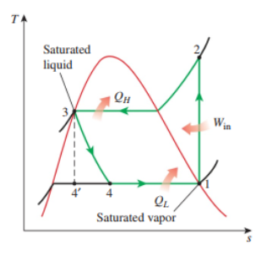
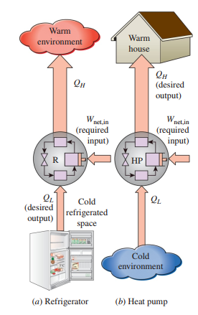
Figure 8-1: Difference between refrigerators along with T-s diagram of cycle
The basic components and their working in forward and reversed vapor compression system is same and both work on same thermodynamic cycle. As far as the performance of the system is concerned, the performance is measured in terms of Coefficient of performance (COP) or also called (Performance Factor) in case of heat pump. With reference to the above T-s diagram, the COP of heat pump can be written as,
${COP}_{hp}= {PF}_{hp}= \frac{Q_{H}}{W_{C}}= \frac{q_{h}}{w_{c}}= \frac{\dot{Q_{H}}}{\dot{W_{C}}}= \frac{Q_{H}}{W_{in}}$ (2-1)
With the help of a little calculation nit can also be proved for the refrigerator and heat pump operating between the same temperature limits, the ${COP}_{hp}$ is greater than ${COP}_{Ref}$and the relation is shown in equation (2-2).
${COP}_{hp}= {COP}_{Ref}+1$ (2-2)
This relation implies that the coefficient of performance of a heat pump is always greater than unity since COPR is a positive quantity. That is, a heat pump will function, at worst, as a resistance heater, supplying as much energy to the house as it consumes. In reality, however, part of QH is lost to the outside air through piping and other devices, and COPHP may drop below unity when the outside air temperature is too low. When this happens, the system usually switches to a resistance heating mode. Most heat pumps in operation today have a seasonally averaged COP of 2 to 3.

8.5 Experimental Setup
The apparatus used in this experiment is shown in following figure. The apparatus is based on all basic components of vapor compression refrigeration as used in experiment No.1.
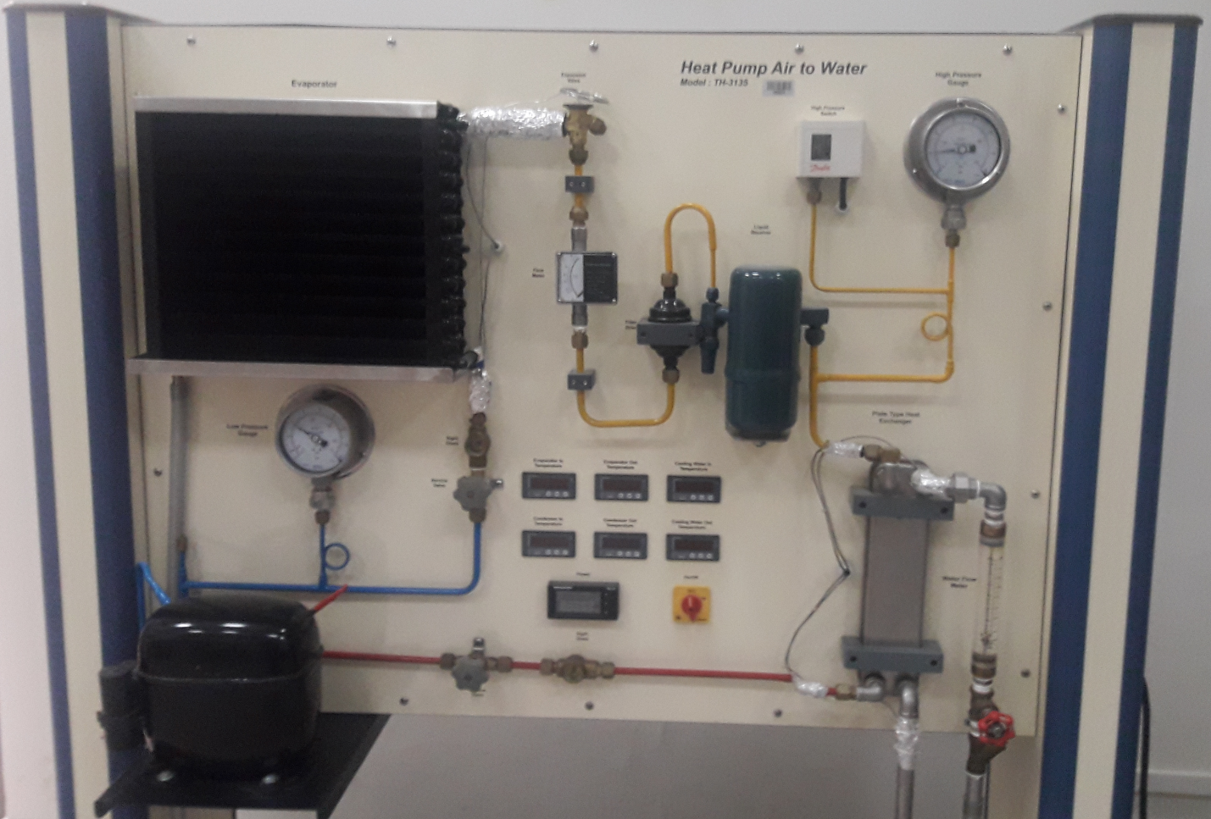
Figure 8-2: T-H 3135 heat pump air to water
However, it should be noted that the heat pump apparatus is not based on inverter technology as discussed previously. It is in fact forward cycle with the provision of water cooled plate type counter flow heat exchanger (condenser). The focus lies on plate type heat exchanger and to study how during the condensation of refrigerant the cooling water is being heated. In order to control the flow rate of water a flow control valve and a rotameter is installed. The expansion devise being used is thermostatic expansion valve. For condenser and evaporator pressure monitoring, high-pressure and low-pressure gauges are installed.

8.6 Experimental Procedure
(To be written by student in Times New Roman, 12. The procedure must be in form of points and provide precautions at the end. The contents of procedure and precautions must not be less than both sides of this page. Unnecessary spaces will lead to negative impression on award.)

8.7 Observations
Table 8-1: Observations for experiment 8
Sr.No | Variable | Unit | Trial-I | Trial-II | Trial-III | Trial-IV
1. | Refrigerant Volume Flow rate | (Ltr/min)
2. | Cooling water Volume flow rate | Ltr/min)
3. | Low Pressure | (Bar)
4. | High Pressure | (Bar)
5. | Evaporator Inlet Temp | (^{O}C)
6. | Evaporator outlet Temp | (^{O}C)
7. | Condenser inlet temperature | (^{O}C)
8. | Condenser outlet temperature | (^{O}C)
9. | Cooling water inlet temperature | (^{O}C)
10. | Cooling water oulet temperature | (^{O}C)
11. | Compressor power | (Watt)

8.8 Calculations
Table 8-2: Calculations for experiment 8
Sr.No | Volume flow rate of water  $$\dot{(V)}$$ | Mass flow rate  $$\dot{(m)}$$ | Cooling water inlet temperature (Tin,water) | Cooling water out temperature  (Tout,water) | Compressor work  $$\dot{W}$$ | Heat delivered  $$\dot{Q}=\dot{m} CpΔT$$ | COP_{hp}  ($\frac{\dot{Q}}{\dot{W}}$)
 | Ltr/sec | Kg/sec | (^{O}C) | (^{O}C) | (Watt) | (Watt)

Figure 8-3: P-h diagram for R134-a

Figure 8-4: P-h diagram for R134-a

Figure 8-5: P-h diagram for R134-a

Figure 8-6: P-h diagram for R134-a

8.9 Discussion and Conclusion
(Must be written by student in Times New Roman, 12. Also give conclusion at the end. The contents of discussion and conclusion must not be less than two sides of this page.)

EXPERIMENT 9
Date: ________________
ABSTRACT

(Abstract to be written in Times New Roman, 12, Justify)

Experiment 9
Performance study of Pump-less Vapor absorption Refrigeration cycle

9.1 Learning Objective
- To revise the basic theory of vapor absorption system.
- To understand the operation of basic components of vapor absorption system.
- To determine the performance of vapor compression system with different heat loads.

9.2 List of Equipment
- TH-3133 Refrigeration Trainer (Absorption Type)

9.3 Introduction
(To be written by students in Times New Roman, 12.)

9.4 Theory
Vapor absorption refrigeration system is a system that uses thermal energy to replace the function of compressor in vapor compression refrigeration system. The fundamental principle of vapor absorption was discovered by Michael Faraday in 1824 and Ferdinand Carre, a French scientist received United States patent for absorption based refrigeration system in 1860.
The absorption refrigeration system, like vapor compression system contains condenser, expansion device and evaporator but the difference exists in the mechanism of vapor compression from low temperature-low pressure state to high temperature-high pressure state.
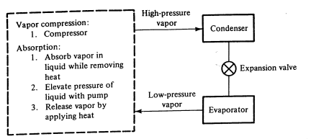
Figure 9-1: A simple schematic diagram of vapor absorption system
The vapor compression system simply uses mechanical compressor for this purpose while absorption system execute compression process in three stages,
- Absorption of low temperature-low pressure refrigerant vapors into an absorbent while constant removal of heat released by vapors.
- Elevating the pressure of refrigerant-vapor liquid mixture using pump.
- Releasing of refrigerant vapors from the mixture using heat.
The whole process is shown through a schematic diagram in fig. It is now clear that Vapor absorption system uses heat energy for compression process and vapor compression system uses mechanical work for vapor compression therefore vapor absorption cycle is also called heat operated cycle and vapor compression cycle is also called work operated cycle. Absorption system become favorable where conventional fuels are economical or where excessive amount of waste heat or solar thermal energy is available.

9.4.1 Simple Vapor Absorption System
As discussed previously that the vapor absorption system, like vapor compression system contains condenser, expansion valve and evaporator but the compression process is carried out by a combination of three components called absorber, solution pump, generator and throttling valve. These four components form what we generally call as a thermal compressor. A simple vapor absorption system is shown in following fig.
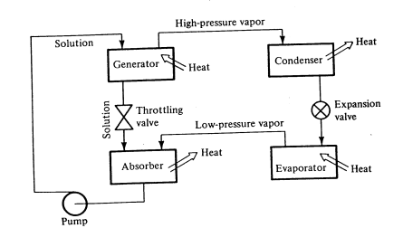
Figure 9-2: A simple vapor absorption system
Low temperature, low pressure refrigerant leaving the expansion device, after absorbing latent heat in evaporator, transforms into saturated vapor. Theses saturated vapors are than routed to absorber where they are absorbed by absorbent liquid. Most common and widely used combination of refrigerant-absorbent mixture is LiBr-H₂O combination. In this combination aqueous solution of Lithium Bromide serves as absorbent and water serves as refrigerant. The other combination include NH₃-H₂O i.e. Ammonia Water system or also called Aqua Ammonia system in which NH₃ serves as refrigerant and H₂O serves as refrigerant. LiBr-H₂O based system are most widely used system in commercial and industrial air-condition systems and NH₃-H₂O based systems are mostly used when temperature requirement are below 0⁰C.
While the refrigerant vapors are absorbed in the absorbing liquid, they release latent heat of vaporization. The release of latent heat tends to increase the temperature of absorber, it is therefore necessary to continuously remove the heat from absorber as the rise in temperature will have adverse effect on absorption process.
The refrigerant-vapor mixture in absorber is called strong solution as it has higher concentration of refrigerant. This strong solution is the passed through the pump so it is delivered to generator at elevated pressure. Generator is a sort of boiler that uses heat energy to boil the vapor-absorbent mixture. At the generator conditions the high temperature and high pressure refrigerant than boils and transforms into vapor. These vapors than enter into generator and cycle continues.

9.4.2 Characteristics of Refrigerant-Absorbent Combination
The desirable properties of refrigerant-absorbent mixtures for VARS are:
- The refrigerant should exhibit high solubility with solution in the absorber. This is to say that it should exhibit negative deviation from Raoult’s law at absorber.
- There should be large difference in the boiling points of refrigerant and absorbent (greater than 200oC), so that only refrigerant is boiled-off in the generator. This ensures that only pure refrigerant circulates through refrigerant circuit (condenser-expansion valve-evaporator) leading to isothermal heat transfer in evaporator and condenser
- The refrigerant-absorbent mixture should have high thermal conductivity and low viscosity for high performance.
- It should not undergo crystallization or solidification inside the system.
- The mixture should be safe, chemically stable, non-corrosive, and inexpensive and should be available easily.

9.4.3 Pumpless Vapor Absorption System
Conventional absorption refrigeration systems use a mechanical pump for
pumping the solution from absorber pressure to generator pressure. However, there
are also absorption refrigeration systems that do not require a mechanical pump.
These systems offer several advantages over conventional systems such as:
- High reliability due to absence of moving parts
- Very little maintenance
- Systems require only low grade thermal energy.
- Silent operation
Due to the above advantages the pump-less systems find applications such as
refrigerators for remote and rural areas, portable refrigerators, refrigerators for luxury
hotel rooms etc.
Several pumpless systems using both water-lithium bromide and ammonia-water have been developed over the last many decades. However, among these the most popular and widely used system is the one known as Platen-Munters system or Triple Fluid Vapour Absorption Refrigeration System (TFVARS). This system was developed by Platen and Munters of Sweden in 1930s. It uses ammonia as refrigerant and water as absorbent and hydrogen as an inert gas. Unlike conventional systems, the total pressure is constant throughout the Platen-Munters system, thus eliminating the need for mechanical pump or compressor. To allow the refrigerant (ammonia) to evaporate at low temperatures in the evaporator, a third inert gas (hydrogen) is introduced into the evaporator-absorber of the system. Thus, even though the total pressure is constant throughout the system, the partial pressure of ammonia in evaporator is much smaller than the total pressure due to the presence of hydrogen.

9.4.4 Fundamental Principle of Pumpless Vapor Absorption System
Although many companies have variations of the basic system, the principle of operation remains the same. When the burner is lighted or heater is turned on and its head applied to the generator at 1 in Fig below, ammonia vapor is released from the solution. This hot vapor passes upward through the percolator tube at 2. As the hot ammonia vapor rises through this tube, it carries the solution to the upper level of the separator at 3.Most of the liquid solution settles in the bottom of the separator and flows into the absorber. The hot ammonia vapor, being light, rises to the top of the tube, marked 4, into the condenser. The hot ammonia vapor then condenses into a liquid. Then ammonia is now in pure state and it flows by gravity into the evaporator.

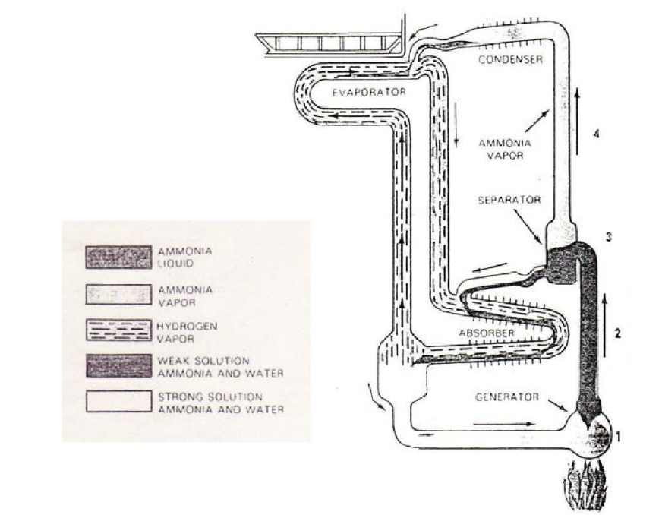
Figure 9-3: Pumpless vapor absorption system
Because a liquid will always seek its own level, the liquid ammonia flows through the liquid ammonia tube and spills into the evaporator. There it forms in large shallow pools on a series of horizontal baffle plates. The hydrogen gas that is being fed to the evaporator in large quantities permits the liquid ammonia to evaporate at a low pressure and at a low temperature (Dalton’s principle). During this process of evaporation, the ammonia absorbs heat from the food compartment of the refrigerator and causes the water in the ice cube containers to freeze. The more hydrogen and less ammonia, the lower the temperature. The evaporated ammonia mixes with the hydrogen gas.
Meanwhile, a weak solution of ammonia and water, is flowing by gravity from the separator, at 3, down to the top of the absorber. Here it meets the mixture of hydrogen gas and ammonia vapor coming from the evaporator. The weak and fairly cool solution absorbs the ammonia vapor. The hydrogen gas is left free since hydrogen will not mix the water. Because the hydrogen is also very light, it now rises to the top of the absorber and returns to the evaporator. Being air cooled, the absorber has fins. The cooling of the weak solution helps it to reabsorb the ammonia gas out of the mixture of ammonia vapor and hydrogen gas.
As the weak water solution reabsorbs the ammonia vapor, considerable heat is liberated. The air-cooled fins remove this heat to permit refrigeration to continue. The ammonia liquid and water mixture flows back to the generator, where it again starts its cycle.

9.5 Experimental Setup
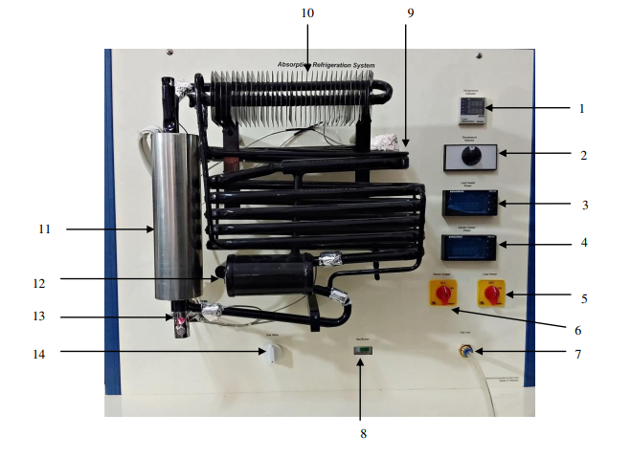
Figure 9-4: Pumpless vapor absorption system apparatus
The apparatus is TH-3133 Refrigeration Trainer (Absorption Type) a welded assembly. There are no moving parts to wear-out or get out of adjustment. Since the total pressure throughout the cycle is about 400 psi (2864 kPa) at a room (ambient) temperature of 100°F (38°C), construction must be rugged to insure a long life. To produce a temperature of 0°F (-18°C) in the evaporator, the ammonia must boil at 15.7 psi (211.8 kPa). This means the hydrogen must make up the reminder of the pressure (384.3 psi). The nomenclature of instrumentation of the apparatus is given in following table.

9.5.1 Apparatus Flow Diagram
The heat is supplied by a burner which is fitted underneath the central tube (A) and when the unit operates on electricity the heat is supplied by a heating element inserted in the pocket (B).The unit charge consists of a quantity of ammonia, water and hydrogen at a sufficient pressure to condense ammonia at the room temperature for which the unit is designed. When heat is supplied to the boiler system, bubbles of ammonia gas are produced which rise and carry with them
quantities of weak ammonia solution through the siphon pump (C). This weak solution passes into the tube (D), whilst the ammonia vapor passes into the vapor pipe (E) and on to the water separator. Here any water vapor is condensed and runs back into the boiler system leaving the dry ammonia vapor to pass to the condenser. Air circulating over the fins of the condenser removes heat from the ammonia vapor to cause it to condense to liquid ammonia in which state it flows into the evaporator. The evaporator is supplied with hydrogen. The hydrogen passes across the surface of the ammonia and lowers the ammonia vapor pressure sufficiently to allow the liquid ammonia to evaporate.
The evaporation of the ammonia extracts heat from the food storage space, as described above, thereby lowering the temperature inside the refrigerator. The mixture of ammonia and hydrogen vapor passes from the evaporator to the absorber. Entering the upper portion of the absorber is a continuous trickle of weak ammonia solution fed by gravity from the tube (D). This weak solution, flowing down through the absorber comes into contact with the mixed ammonia and hydrogen gases which readily absorbs the ammonia from the mixture, leaving the hydrogen free to rise through the absorber coil and to return to the evaporator. The hydrogen thus circulates
continuously between the absorber and the evaporator.

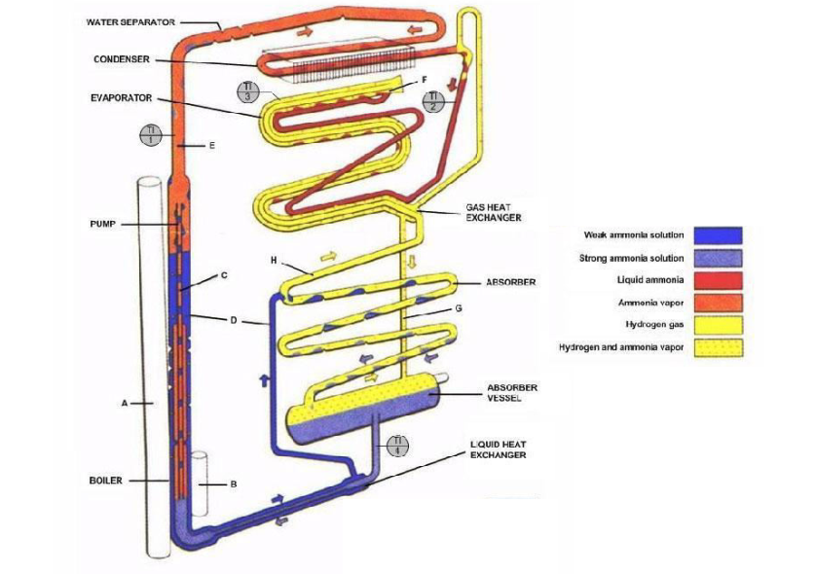
Figure 9-5: Apparatus flow diagram
The strong ammonia solution produced in the absorber flows down to the absorber vessel and thence to the boiler system, thus completing the full cycle of operation. The liquid circulation of the unit is purely gravitational. Heat is generated in the absorber by the process of absorption. This heat must be dissipated into the surrounding air. Heat must also be dissipated from the
condenser in order to cool the ammonia vapor sufficiently for it to liquefy. Free air circulation is therefore necessary over the absorber and condenser. The whole unit operates by the heat applied to the boiler system and it is of paramount importance that this heat is kept within the necessary limits and is properly applied.

9.6 Experimental Procedure
(To be written by student in Times New Roman, 12. The procedure must be in form of points and provide precautions at the end. The contents of procedure and precautions must not be less than both sides of this page. Unnecessary spaces will lead to negative impression on award.)

9.7 Observations
Table 9-1: Observations for experiment 9
Sr.No | Power | T₁ | T₂ | T₃ | T₄ | T₅ | T₆ | COP (Carnot)
-- | (Wat) | (^{O}C) | (^{O}C) | (^{O}C) | (^{O}C) | (^{O}C) | (^{O}C)
1
2
3
4
5
6
Where, COP _{carnot} = $\frac{Tevap(Tgen-Tabs,cond)}{Tgen(Tabs,cond-Tevp)}$
T1 = Condenser inlet temperature
T2 = Condenser outlet temperature
T3 = Evaporator inlet temperature
T4 = Absorber inlet temperature
T5 = Absorber vessel inlet temperature
T6 = Generator inlet temperature
T7 = Ambient Temperature


9.8 Discussion and Conclusion
(Must be written by student in Times New Roman, 12. Also give conclusion at the end. The contents of discussion and conclusion must not be less than two sides of this page.)

EXPERIMENT 10
Date: ________________
ABSTRACT

(Abstract to be written in Times New Roman, 12, Justify)

Experiment 10
Performance Study of a Cooling Tower.

10.1 Learning Objectives
- To learn the basics and classifications of cooling towers.
- To study the performance of forced draft, counterflow cooling tower.

10.2 List of Equipment
- Cooling tower

10.3 Introduction
(To be written by students in Times New Roman, 12.)

10.4 Theory
Cooling towers are a very important part of many chemical plants. The primary task of a cooling tower is to reject heat into the atmosphere. They represent a relatively inexpensive and
dependable means of removing low-grade heat from cooling water. The make-up water source
is used to replenish water lost to evaporation. Hot water from heat exchangers is sent to the
cooling tower. The water exits the cooling tower and is sent back to the exchangers or to other
units for further cooling. Figure 1 shows a schematic of cooling towers.
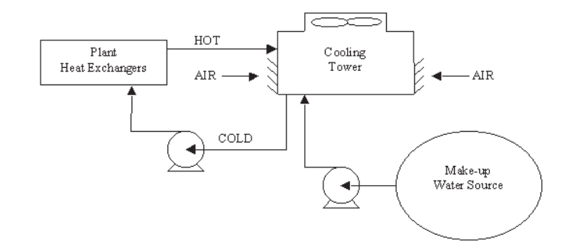
Figure 10-1: Cooling tower schematic
Cooling towers are designed and manufactured in several types, with numerous sizes (models) available in each type. Not all types are suitable for application to every heat load configuration. Understanding the various types, along with their advantages and limitations, can be of vital importance to the prospective user.
Cooling towers fall into two main categories: Natural draft and Mechanical draft.
Natural draft towers use very large concrete chimneys to introduce air through the media.
Due to the large size of these towers, they are generally used for water flow rates above 45,000
m3/hr. These types of towers are used only by utility power stations.
Mechanical draft towers utilize large fans to force or suck air through circulated water. The
water falls downward over fill surfaces, which help increase the contact time between the water
and the air - this helps maximize heat transfer between the two. Cooling rates of Mechanical
draft towers depend upon their fan diameter and speed of operation. Mechanical draft
cooling towers are much more widely used.
Based on type of airflow, following classifications of cooling towers can be made.
- Counter flows induced draft
- Counter flow forced draft
- Cross flow induced draft
In the counter flow induced draft design, hot water enters at the top, while the air is introduced at the bottom and exits at the top. Both forced and induced draft fans are used.
In cross flow induced draft towers, the water enters at the top and passes over the fill. The
air, however, is introduced at the side either on one side (single-flow tower) or opposite sides
(double-flow tower). An induced draft fan draws the air across the wetted fill and expels it
through the top of the structure.
Mechanical draft towers are available in a large range of capacities. Normal capacities range from approximately 10 tons, 2.5 m³/hr flow to several thousand tons and m³/hr. Towers can be either factory built or field erected - for example concrete towers are only field erected.
Many towers are constructed so that they can be grouped together to achieve the desired
capacity. Thus, many cooling towers are assemblies of two or more individual cooling
towers or cells. The number of cells they have, e.g., an eight-cell tower, often refers to
such towers. Multiple-cell towers can be lineal, square, or round depending upon the shape
of the individual cells and whether the air inlets are located on the sides or bottoms of the
cells.

10.4.1 Components of Cooling Tower
The basic components of an evaporative tower are: Frame and casing, fill, cold water basin,
drift eliminators, air inlet, louvers, nozzles and fans.
Frame and casing: Most towers have structural frames that support the exterior enclosures
(casings), motors, fans, and other components. With some smaller designs, such as some glass
fiber units, the casing may essentially be the frame.
Fill: Most towers employ fills (made of plastic or wood) to facilitate heat transfer by maximizing water and air contact. Fill can either be splash or film type. With splash fill, water falls over successive layers of horizontal splash bars, continuously breaking into smaller droplets, while also wetting the fill surface. Plastic splash fill promotes better heat transfer than the wood splash fill.
Film fill consists of thin, closely spaced plastic surfaces over which the water spreads, forming a thin film in contact with the air. These surfaces may be flat, corrugated, honeycombed, or
other patterns. The film type of fill is the more efficient and provides same heat transfer in a smaller volume than the splash fill.
Cold water basin: The cold-water basin, located at or near the bottom of the tower, receives
the cooled water that flows down through the tower and fill. The basin usually has a sump or
low point for the cold-water discharge connection. In many tower designs, the cold-water basin
is beneath the entire fill. In some forced draft counter flow design, however, the water at the bottom of the fill is channeled to a perimeter trough that functions as the cold-water basin. Propeller fans are mounted beneath the fill to blow the air up through the tower. With this design, the tower is mounted on legs, providing easy access to the fans and their motors.
Drift eliminators: These capture water droplets entrapped in the air stream that otherwise
would be lost to the atmosphere.
Air inlet: This is the point of entry for the air entering a tower. The inlet may take up an entire
side of a tower–cross flow design– or be located low on the side or the bottom of counter flow
designs.
Louvers: Generally, cross-flow towers have inlet louvers. The purpose of louvers is to equalize air flow into the fill and retain the water within the tower. Many counter flow tower designs
do not require louvers.
Nozzles: These provide the water sprays to wet the fill. Uniform water distribution at the top of
the fill is essential to achieve proper wetting of the entire fill surface. Nozzles can either be
fixed in place and have either round or square spray patterns or can be part of a rotating assembly as found in some circular cross-section towers.
Fans: Both axial (propeller type) and centrifugal fans are used in towers. Generally, propeller
fans are used in induced draft towers and both propeller and centrifugal fans are found in forced
draft towers. Depending upon their size, propeller fans can either be fixed or variable pitch.
A fan having non-automatic adjustable pitch blades permits the same fan to be used over a wide
range of kW with the fan adjusted to deliver the desired air flow at the lowest power consumption.
Automatic variable pitch blades can vary air flow in response to changing load conditions.

10.4.2 Cooling Tower Performance Parameters
Range: Range is the difference between the cooling tower water inlet and outlet temperature. Range is determined not by the cooling tower, but by the process it is serving. The range at the
exchanger is determined entirely by the difference between the temperature at the inlet and at the outlet of the cooling tower.
$$Range \left(°C\right)= Inlet temperature \left(°C\right)-Outlet temperature(°C)$$
Approach: Approach is the difference between the cooling tower outlet cold water temperature
and ambient wet bulb temperature. Although, both range and approach should be monitored, the approach is a better indicator of cooling tower performance.
As a generalization, the closer the approach to the wet bulb, the more expensive the cooling tower due to increased size. Usually a 2.8°C approach to the design wet bulb is the coldest water temperature that cooling tower manufacturers will guarantee. If flow rate, range, approach and wet bulb had to be ranked in the order of their importance in sizing a tower, approach would be first with flow rate closely following the range and wet bulb would be of lesser importance.
Wet Bulb Temperature: Wet bulb temperature is an important factor in performance of evaporative water-cooling equipment. It is a controlling factor from the aspect of minimum cold-water temperature to which water can be cooled by the evaporative method. Thus, the wet bulb temperature of the air entering the cooling tower determines operating temperature levels throughout the plant, process, or system. Theoretically, a cooling tower will cool water to the entering wet bulb temperature, when operating without a heat load. However, a thermal potential is required to reject heat, so it is not possible to cool water to the entering air wet bulb temperature, when a heat load is applied. The approach obtained is a function of thermal conditions and tower capability.
Effectiveness: Cooling tower effectiveness (in percentage) is the ratio of range, to the ideal range, i.e., difference between cooling water inlet temperature and ambient wet bulb temperature, or in other words:
$$Effectiveness= \frac{Range}{Range+Approach}$$

10.5 Experimental Procedure
(To be written by student in Times New Roman, 12. The procedure must be in form of points and provide precautions at the end. The contents of procedure and precautions must not be less than both sides of this page. Unnecessary spaces will lead to negative impression on award.)

10.6 Observations and Calculations
Table 10-1: Observations and calculations for experiment 10
Sr.No | Hot Water Temperature | Cold Water Temperature | Ambient Wet Bulb Temperature | Outlet Wet Bulb Temperature | Range | Approach | Effectiveness
-- | (^{O}C) | (^{O}C) | (^{O}C) | (^{O}C) | (^{O}C) | (^{O}C)
1
2
3
4
5
6

10.7 Discussion and Conclusion
(Must be written by student in Times New Roman, 12. Also give conclusion at the end. The contents of discussion and conclusion must not be less than two sides of this page.)

